**A More Natural HCI based on Ultrasonic Wave Gesture Recognition**

**ABSTRACT**

Using smart mobile devices method could be improved in numerous ways with the help of in-air gesture recognition. Most scenarios are proposed by academia and industry and based on special sensors. Gesture interactive have become an increasingly popular means of in- teracting with computers. In order to do this, the specialist has generated an inaudible tone, getting frequency-shifted as it reflects off moving objects like the hand. Measuring this shift with the microphone to infer various gestures. In this project, we describe the phexnomena and detection algorithm, demonstrate a variety of gestures.

**Categories and Subject Descriptors**

D.3.3 [**Programming Languages**]: Language Constructs and Features – *abstract data types, polymorphism, control structures.* This is just an example, please use the correct category and subject descriptors for your submission*.*

**General Terms**

Your general terms must be any of the following 16 designated terms: Algorithms, Management, Measurement, Documentation, Performance, Design, Economics, Reliability, Experimentation, Security, Human Factors, Standardization, Languages, Theory, Legal Aspects, Verification.

**Keywords**

In-air gesture sensing; Doppler; interaction technique.

**1. INTRODUCTION**

In recent years there has been many new non-contact human-computer interaction technologies, most of which are based on computer vision. But most of the gesture-based interactive methods of computer vision are sensitive to light, it requires higher computational complexity and more system, so the computer visual non-contact gesture interaction technology is not applicable to future wearable technology.

Taking into account the above factors，more and more experts have begun to study the use of ultrasound for gesture recognition. Considering the miniaturization of wearable equipment, limited performance and power, this research presents an opportunity for ultrasonic low-power hand gesture recognition method. The ultrasonic wave gesture recognition comes with the microphone and speakers which emit ultrasonic wave to recollect later. It extracts and analyzes the characteristics of the frequency variation of the acoustic signal caused by the change of the user's gesture, and then identifies the user's gesture.

Human–Computer Interaction (HCI) based on gesture recognition become more and more important, especially for smart mobile devices. Voice, electromyography sensors and brainwave sensors, in-air gesture recognition have more special advantages than HCI based on touch screen in several scenarios, especially in recent years in-air gesture recognition has been improved. It is easy to learn and does not have to contact with the device. The new way based on ultrasonic can perform low computational gesture recognition which does not have to use special equipment, and light or noise will not disturb the gesture. This new approach offers a easier and faster way to operate the device.

In conclusion, we present ultrasonic wave which is a sound-based gesture sensing approach, using the existing audio hardware of mobile devices. This technique uses “Doppler shift” or “Doppler effect”, which identify the sound wave change as a listener closes to or keep away from the sound. A common example is the change in pitch of a vehicle siren as it closes, passes, and then keeps away from the listener. By using this effect, ultrasonic wave could detect the changes around or in front of a computing device, such as the direction, speed and so on. For example, we use as a “rotation” gesture to detect two hands moving in opposite directions in our example applications which is different from vision, ultrasonic wave can detect gestures without line of sight.

**2. TECHNICAL BACKGROUND**

We are not the first to use ultrasonic-based gestures controls in Human Computer Interaction. In recent years, there have been many fantastic and novel non-contact human-computer interaction technologies, most of which are based on computer vision. For example, Kinect is used to reduce the 3D model by sensing the black and white spectrum to perceive user behavior. Relevant gesture recognition work is carried out, while the color map and depth map is captured through RGB-Depth Camera Capture. But the method based on the computer detect and gesture control is relatively sensitive to lightening condition. At the same time, the implementation algorithm is much more complex, which requires more system resources. On the contrary, wearable electronic equipment, whose power are really limited and not equipped with high level professional cameras. So, it may not be a proper way, and the computer-vision based non-contact gestures interactive technology is not suitable for most wearable equipment.

Ultrasonic-based gesture recognition technology, compared with non-contact gesture-based interactive technology which use computer vision, is attracting growing interest of researchers in companies and universities. And the use of ultrasonic human computer interaction has a long history. As early as 1997, Joseph Paradiso et al. [0] invented a new immersion carpet, which percepts the user behavior with the radar sound. This new carpet combined with other sensors in the carpet perceive and translate the user’s various actions and change it to music in real time. Moreover, Junjue Wang et al. [5] proposed a new approach for mobile devices to in put through conventional surfaces with fine-grained localization. Localization of keystrokes is measured by the amplitude spectrum density (ASD) of the click sound which is receipted by the microphone on the cellphone, achieving an accuracy of 95 percent. On the other hand, ultrasonic gesture is also used in image processing area, and it is proved to be extraordinarily useful by Richard J. Przybyla et al. [6]. In their research, an ultrasonic 3D gesture recognize system is presented using a custom transducer chip and an ASIC.

Applications controls are developed based on ultrasonic-based gestures. Many researches have been made on this topic. For example, Tarzia et al. [4] use the microphone on a laptop to measure the intensity of echoes produced by human presence (As shown in Fig 0). Sidhant Gupta et al. [14] concentrate more on the software solutions of ultrasonic-based gestures control, which utilizes speaker and microphone on a personal computer to recognize and detect hand movements, with the use of Fast Fourier Transform algorithm to process the acoustic signal and determine the user’s gestures. This research utilizes Doppler shifts of an inaudible tone at a high frequency of nearly 18kHz and 22kHz. The frequency shifts which happen at this moment were grabbed for two handed gestures as well as more complex gestures like clicking the mouse, double tapping or tapping a key in a short time for many times. Accuracy, however, need to be assured in this process. According to Chunyi Peng et al. [2] high accuracy is usually achieved by measuring time-of-arrival (TOA), which could be interfered by clock skew and drifts between devices, possible misalignment and delay of sound arrival. A pure software-based solution, Beep-Beep ranging mechanism is proposed to overcome all the uncertainties. Specified devices are introduced to recognize gestures based on Doppler effect. An even higher accuracy of prediction at 99.6 percent in ultrasonic gesture recognition is achieved by Kun Jin et al. [7], applying an Artificial Neural Networks (ANNs) method for classification (As shown in Fig X and Fig Y). Kalgaonkar et al. [3] built a low-cost device using Acoustic Doppler Sonar (ADS) with ultrasonic transmitter and three receivers (As shown in Fig 1). By composing signal changes in the multiple location of different areas to create 3D environment to determine user’s gestures, achieving an accuracy of 88.42 percent. This model involves a 40-kHz ultrasonic wave, and the sample frequency is up to 96kHz, ordinary speakers are not suitable for the requirement, while the use of multiple acoustic receivers are not equipped in smaller and versatile wearable equipment. Considering the complexity of the devices and platform, there is limitation adopting this method in a mobile context. Research and application attempts at designing a device like a SoundSense [11], in which four ultrasonic rangefinders are assigned in different edges of the device to find and translate hand gestures. Travis Deyle et al. [12] presents FingerMic, which is a trainable wearable device. This device could detect finger gestures, include for example, like the movement of thumbs, certain hand gesture, or certain gestures corresponding to the shape. Yang Qifan et al. [1] developed a gesture recognition application on Android devices using the loudspeaker and microphone embedded on the cellphone (As shown in Fig 2). They adopt a machine learning approach, and utilized the Doppler shift of ultrasonic reflected by human body moving, achieving a high classification accuracy of 94 percent over a set of 24 pre-defined gestures. However, this application is still in the stage of experimental and has not been widely adopted.

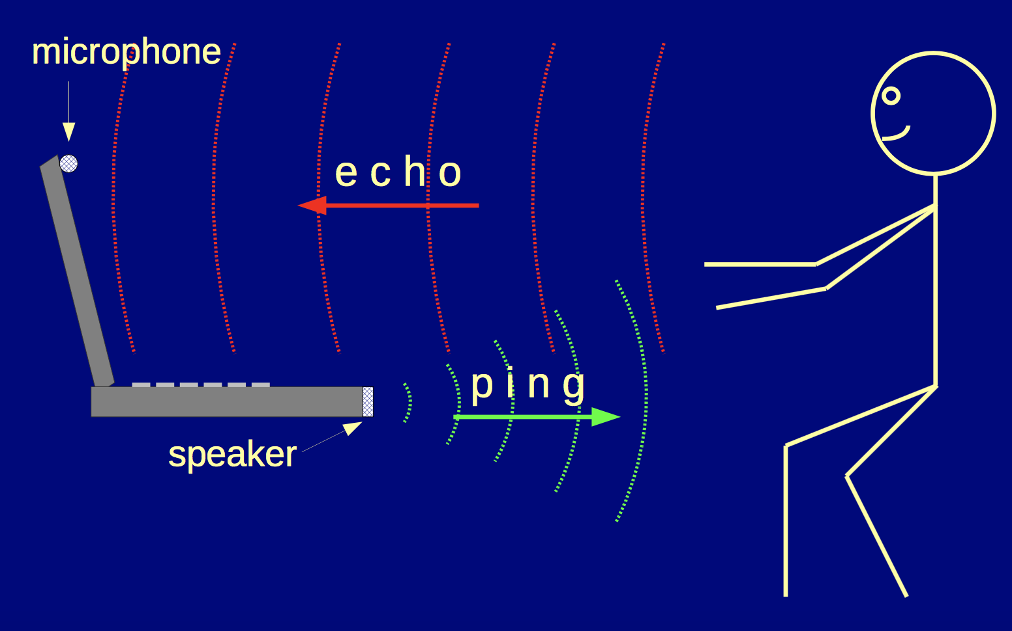

Fig 0. Tarzia’s prototype. Using the microphone on the laptop to detect human attention and presence.

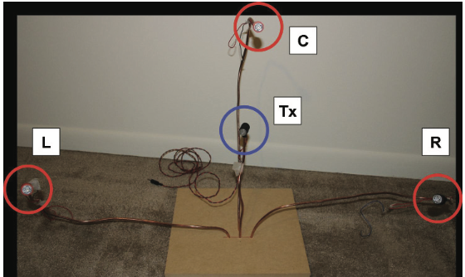

Fig 1. Kaustubh Kalgaonkar’s prototype device. Transmitter in the center and receivers in triangle pattern.

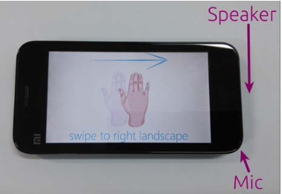

Fig 2. Gesture recognition based on ultrasonic capture on Android mobile device

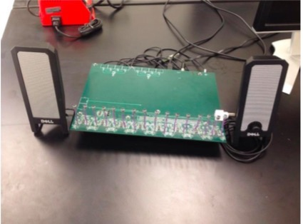

Fig X. Kun’s prototype of ultrasonic gesture recognition model

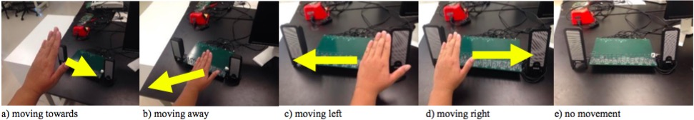





Fig Y. Experiments about recognizing different gestures

**3. DESIGN**

**3.1 Persona**

1. K.P. Steve is 35 year old. And he works in the bank as a commercial manager, he is busy with his work every day. He is in charge of many things such as hosting meeting, guiding the staff and writing reports. Steve really wants to improve work efficiency and high quality finishes work. Next morning Steve will have a meeting with a customer, he wants to show the concept of conference efficiently with high-tech and makes the meeting more vivid.

2. Lily is a 20 years old student at Faculty of Art in The University of New York. She really likes travelling and taking pictures especially taking selfie. Lily is an outgoing girl, she has travelled to many countries. In the summer holiday, Lily travels to Tokyo herself and really enjoys the beautiful landscape, taking a lot of pictures. As she travels by herself and can not take photos with scenery. Her goal is to take pictures with different kinds of landscape.

3. Michael is a 21-year-old college student, majored in Computer Science in HKU. He is kind of nerdy and enjoys video games very much. Owning many infrastructures like Xbox one, PlayStation 4, PC, he has a keen interest in games like Civilization, Skyrim, WOW, Halo and so on. However, most operations are accomplished via joysticks or keyboards, which bugs him a lot. He prefers a more interactive way to manipulate his avatar in a direct way. For example, he may attack an enemy demon with the magic power owned by the avatar by posing some gestures, acting like he is really attacking the demon other than playing with the joystick. Even though there are some technologies like Kinect, they still require good lightening condition, no mention their high prices and energy consumptions. Michael is dying for a more effective way of interaction with relatively reasonable cost and acceptable performance.

4. Tom is a manager of a financial company. He is young and energetic, while the busy daily work really makes him feel tired and stressful. Today he wants to drive to work. Usually when he is driving, he needs to enjoy music. He needs to press a lot of the buttons in order to play music. It is some kind of unsafe since he may not concentrate to driving. Also there always are some important friends who call him when he is driving. So he needs to click the button to answer the phone. He is really tired of the old fashioned interactive ways. He wants new ways to interact with these devices. It should be interesting, creative and also should be safe.

5. Stephen is a researcher in the national aeronautics and national administration. His research interest is to reduce the heavy work of astronauts. Astronauts are always floating in the space capsule because of the zero gravity. Usually the electronic devices and the the food they need to eat is floating inside the space capsule. It could be quite uneasy to move in this such tiny space. They need to save their energy. So Stephen wants a new way to control some electronic equipment in the capsule so that the astronauts could use it without moving.

6.Tom, a 70 years old cardiac patient, he need family members’ help when emergency happens to take medicine for symptom alleviation. However, when the emergency come and no family members nearby, Tom will be dangerous because he will lose control and can not notify others instantly for help. Tom need a intelligent device to detect that emergency and tell other family members to come in time.

7. Jack is a software developer, who fancy new technology and something creative. He like purchase electronic products but he is not satisfied by the current interaction on touch screen. He desire a new natural non-contact interaction method to interact with day-time mobile devices so that he can operate the devices like smart phone naturally with natural gesture and movement instead of scratching on the screen or clicking.

**3.2 Task**

1. When Steve shows the meeting with the ppt, he can use different gestures to help him to turn page and change the size of words. He swipes up his hand to go to the before page and swipes down his hand to turn the page. And handing out of the screen to enlarge the font and handing to the inside of the screen to wipe the font.

2. When Lily wants to take photos, she could find a place to put her phone and choose the gesture model. After she has posed，she just waves her hands toward to the phone. Within 5 seconds, the picture will be taken.

3. A flexible way of interacting with gaming instruments is highly demanded. To fulfill the gap between traditional manipulating methods and these costly complex new interactions like Kinect, trade-off between consumption and performance must be considered. Otherwise, consider the tense atmosphere some games are trying to create, the lightening condition is always poor, which arise a major requirement of light-tolerance. With the help of soundwave reorganization of gestures, Michael will find a more comfortable and costless way to play video games even in poor lightening conditions.

4. A new way to ease Tom’s trouble is we could implement the ultrasonic wave gesture interact with the device. For example, Tom could put his hands near the MP3 player to open the MP3 player. He could shake his hands to select the music. When he wants to play the music, he could put his hands on the top of the screen for a while, the music will be played. When there is a phone call, he could just wave his hands near his mobile, and the phone would detect that and the call would be connected.

5. A new way which could help to solve Stephen’s trouble is to use this ultrasonic wave gesture control system. He could add this system to the tiny space capsule. It won’t take too much space and could be very easy to learn to use. When the astronaut wants to control some thing inside the space capsule. He doesn’t need to move his body and jump forward. It could be as easy as shake his hands and then the remote device would be controlled.

6. When a cardiac patient’s emergency happens, the ultrasonic wave device will detect it and alert family members to come in time.

7. Jack could operate the devices like phone or pad by pose designed gestures based on ultrasonic wave gesture recognition technology. For example, he can switch windows by move his hand horizontally, scroll a table list by translate his hand vertically or select the target element by move close to the device quickly.

**3.3 Function**

Today, the wearable or mobile devices are becoming smaller and smaller and also more power-limited as well. Some traditional human-machine interaction methods like screen touch or gesture recognition based on video can not satisfy that trend and demand, because the screen display is very power-consuming and the device for gesture recognition based on video is too big to be inserted into our mobile devices conveniently. In the near future, it will be inevitable to apply a new natural interaction method as a replace of that current traditional interaction ways.

**3.4 User Interaction Design**

The gesture recognition based on ultrasonic wave is mainly based on Doppler effect and the fact that hand movement could change the wave frequency. The advantages of that is it’s low-power demanding and not mobile device demanding. Take the application on smart phone as an example: we can easily use the phone's speaker to emit voice waves including ultrasonic wave, and then retrieve the wave with the phone's micro-phone. If the user's hand make movements within the valid area, then the frequency of the wave will be changed which means the movement information has been record in it. Besides the wave frequency range that the speaker can generate is 18kHz~22kHz, and human ears' perception frequency range is 20Hz~20kHz, so letting the device emit voice wave of 22kHz will not influent people's life or other bad effects. After retrieve the wave data, then some algorithms will be used to extract and analyze the movement feature so that we can get the move direction information. Then the move direction information will be used as the input of HHM(Hidden Markov Model) to get the final gesture recognition result. In addition, in the phase of the final gesture recognition, a machine learning model will be trained to judge the gesture intelligently.

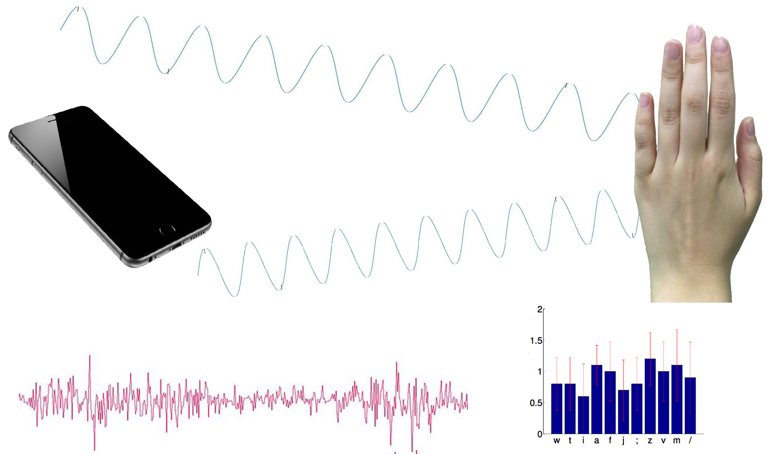

**3.5 Gestural Control**

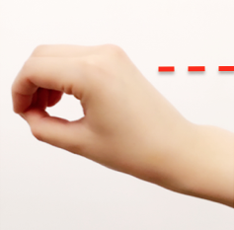 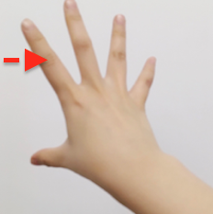

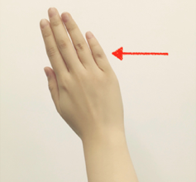 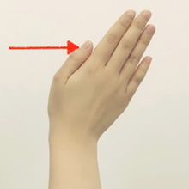

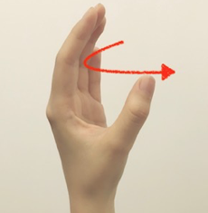 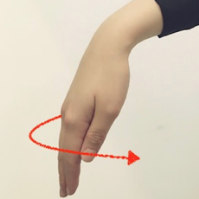

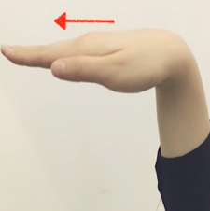 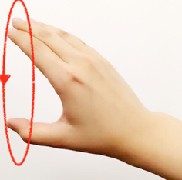

B:back

SB:second back

F: front

SF:second front

N: none

Close:

F---->N

Away:

B---->N

Click：

F---->B---->N

Double click:

F---->B---->SF---->SB---->N

**3.6 Icon Design**

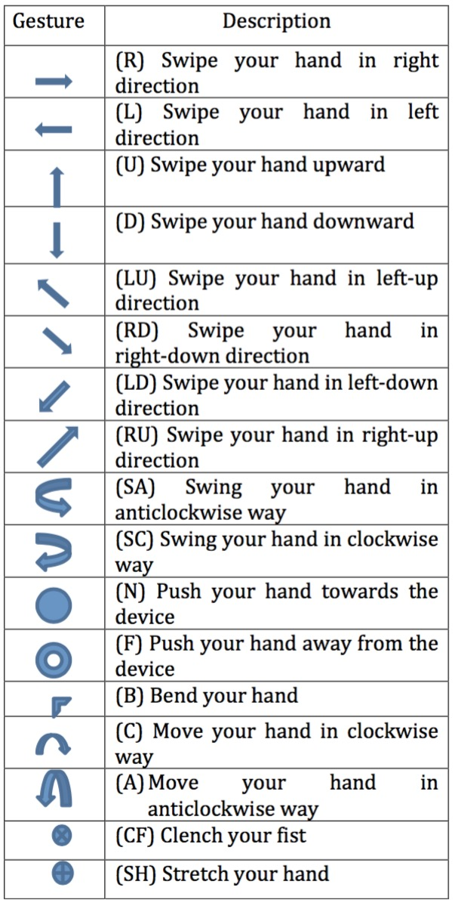

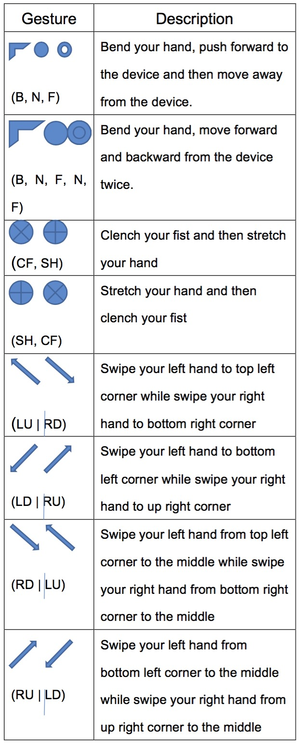

**4. PROTOTYPE IN STORYBOARD**

Because we have finished all the storyboard digital drawing in our prototype, we will use our complete prototype to illustrate the storyboard at the same time. Meanwhile, due to this document format is relative narrow, our prototype diagram is resize into a small size. We have uploaded another document that includes all the diagram in a large size for view and a prototype video. The link for download is below:

**4.1 Scenario 1 Meeting presentation**

The actions taken to implement gesture control in presentation are:

1. Scroll up to see the next page

1.1 Move your hand from downside to upside in front of the microphone speaker of the device.

1. Scroll down to see the previous page

2.1 Move your hand from upside to downside in front of the microphone speaker of the device.

1. Zoom in
   1. Put both hands together in the middle of the displayed screen.
   2. Move your hands apart from each other to opposite directions, aka, move your left hand to top left corner while moving your right to the bottom right corner.
2. Zoom out
   1. Put both hands in opposite corners of the displaying screen, aka, put your right hand in the bottom right corner, while your left in the up left corner.
   2. Gather your hands in the middle of the screen in front of the microphone speaker of the device.

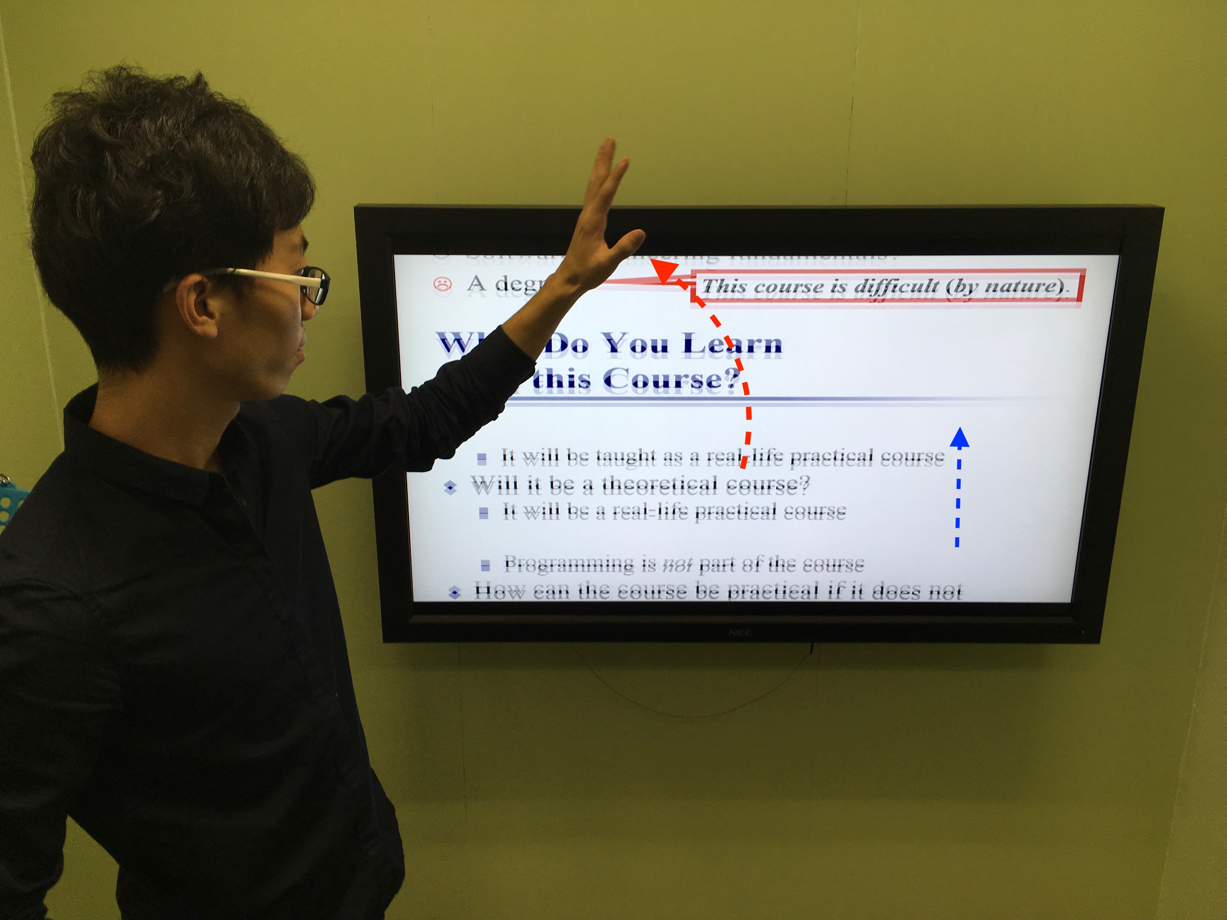 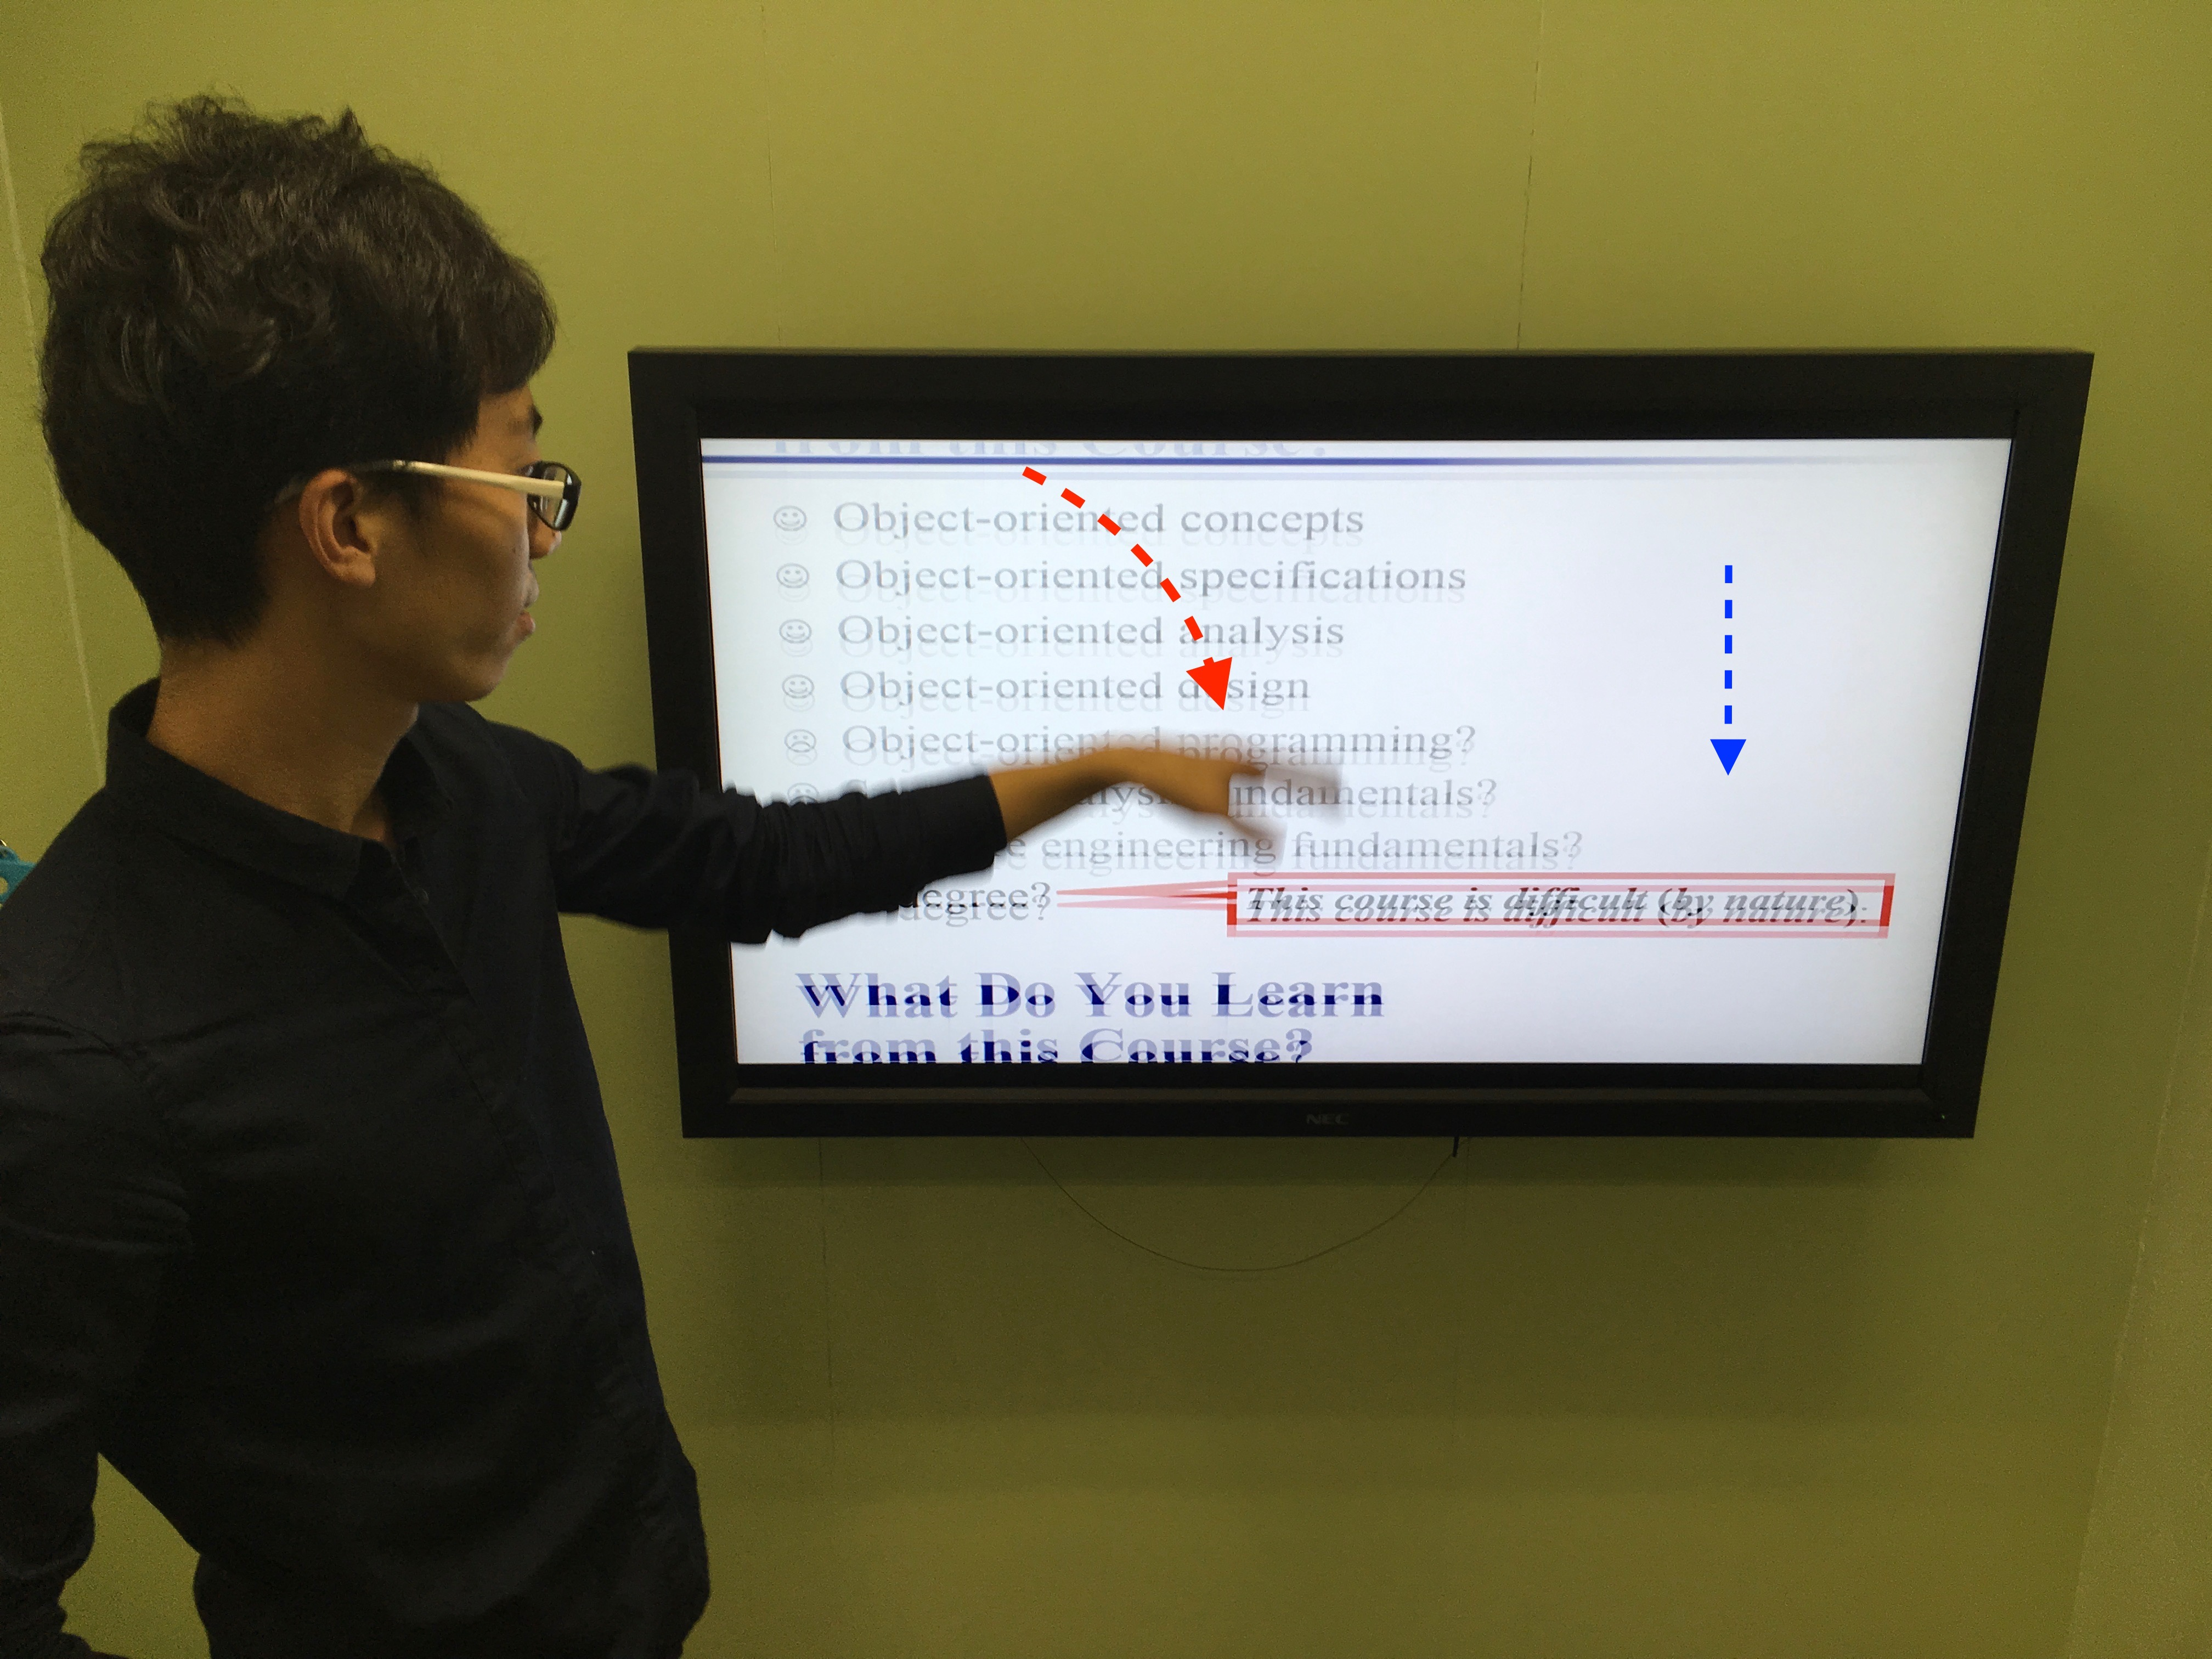

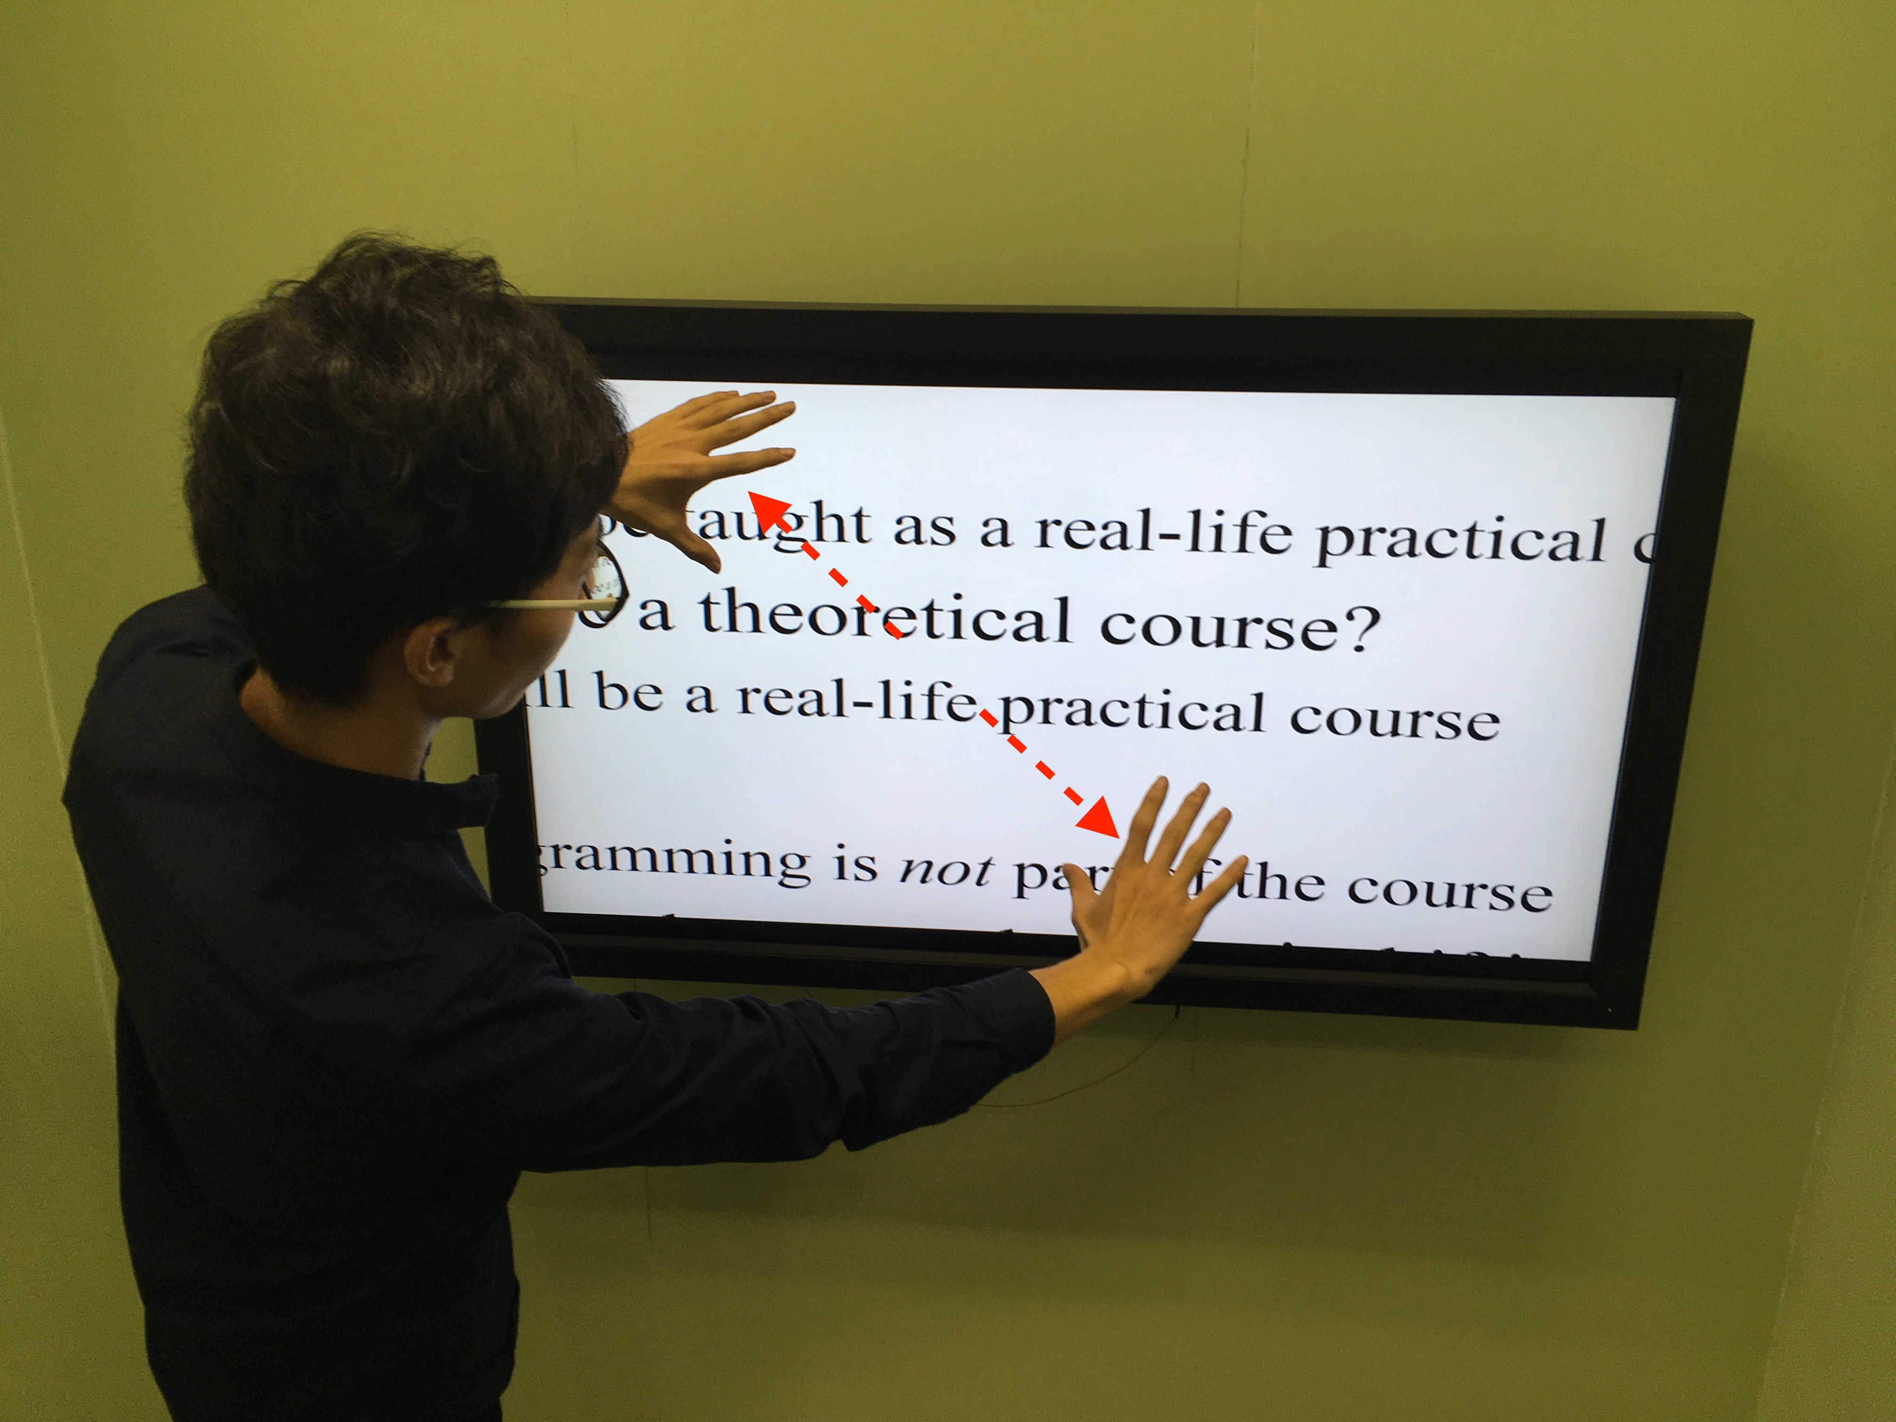 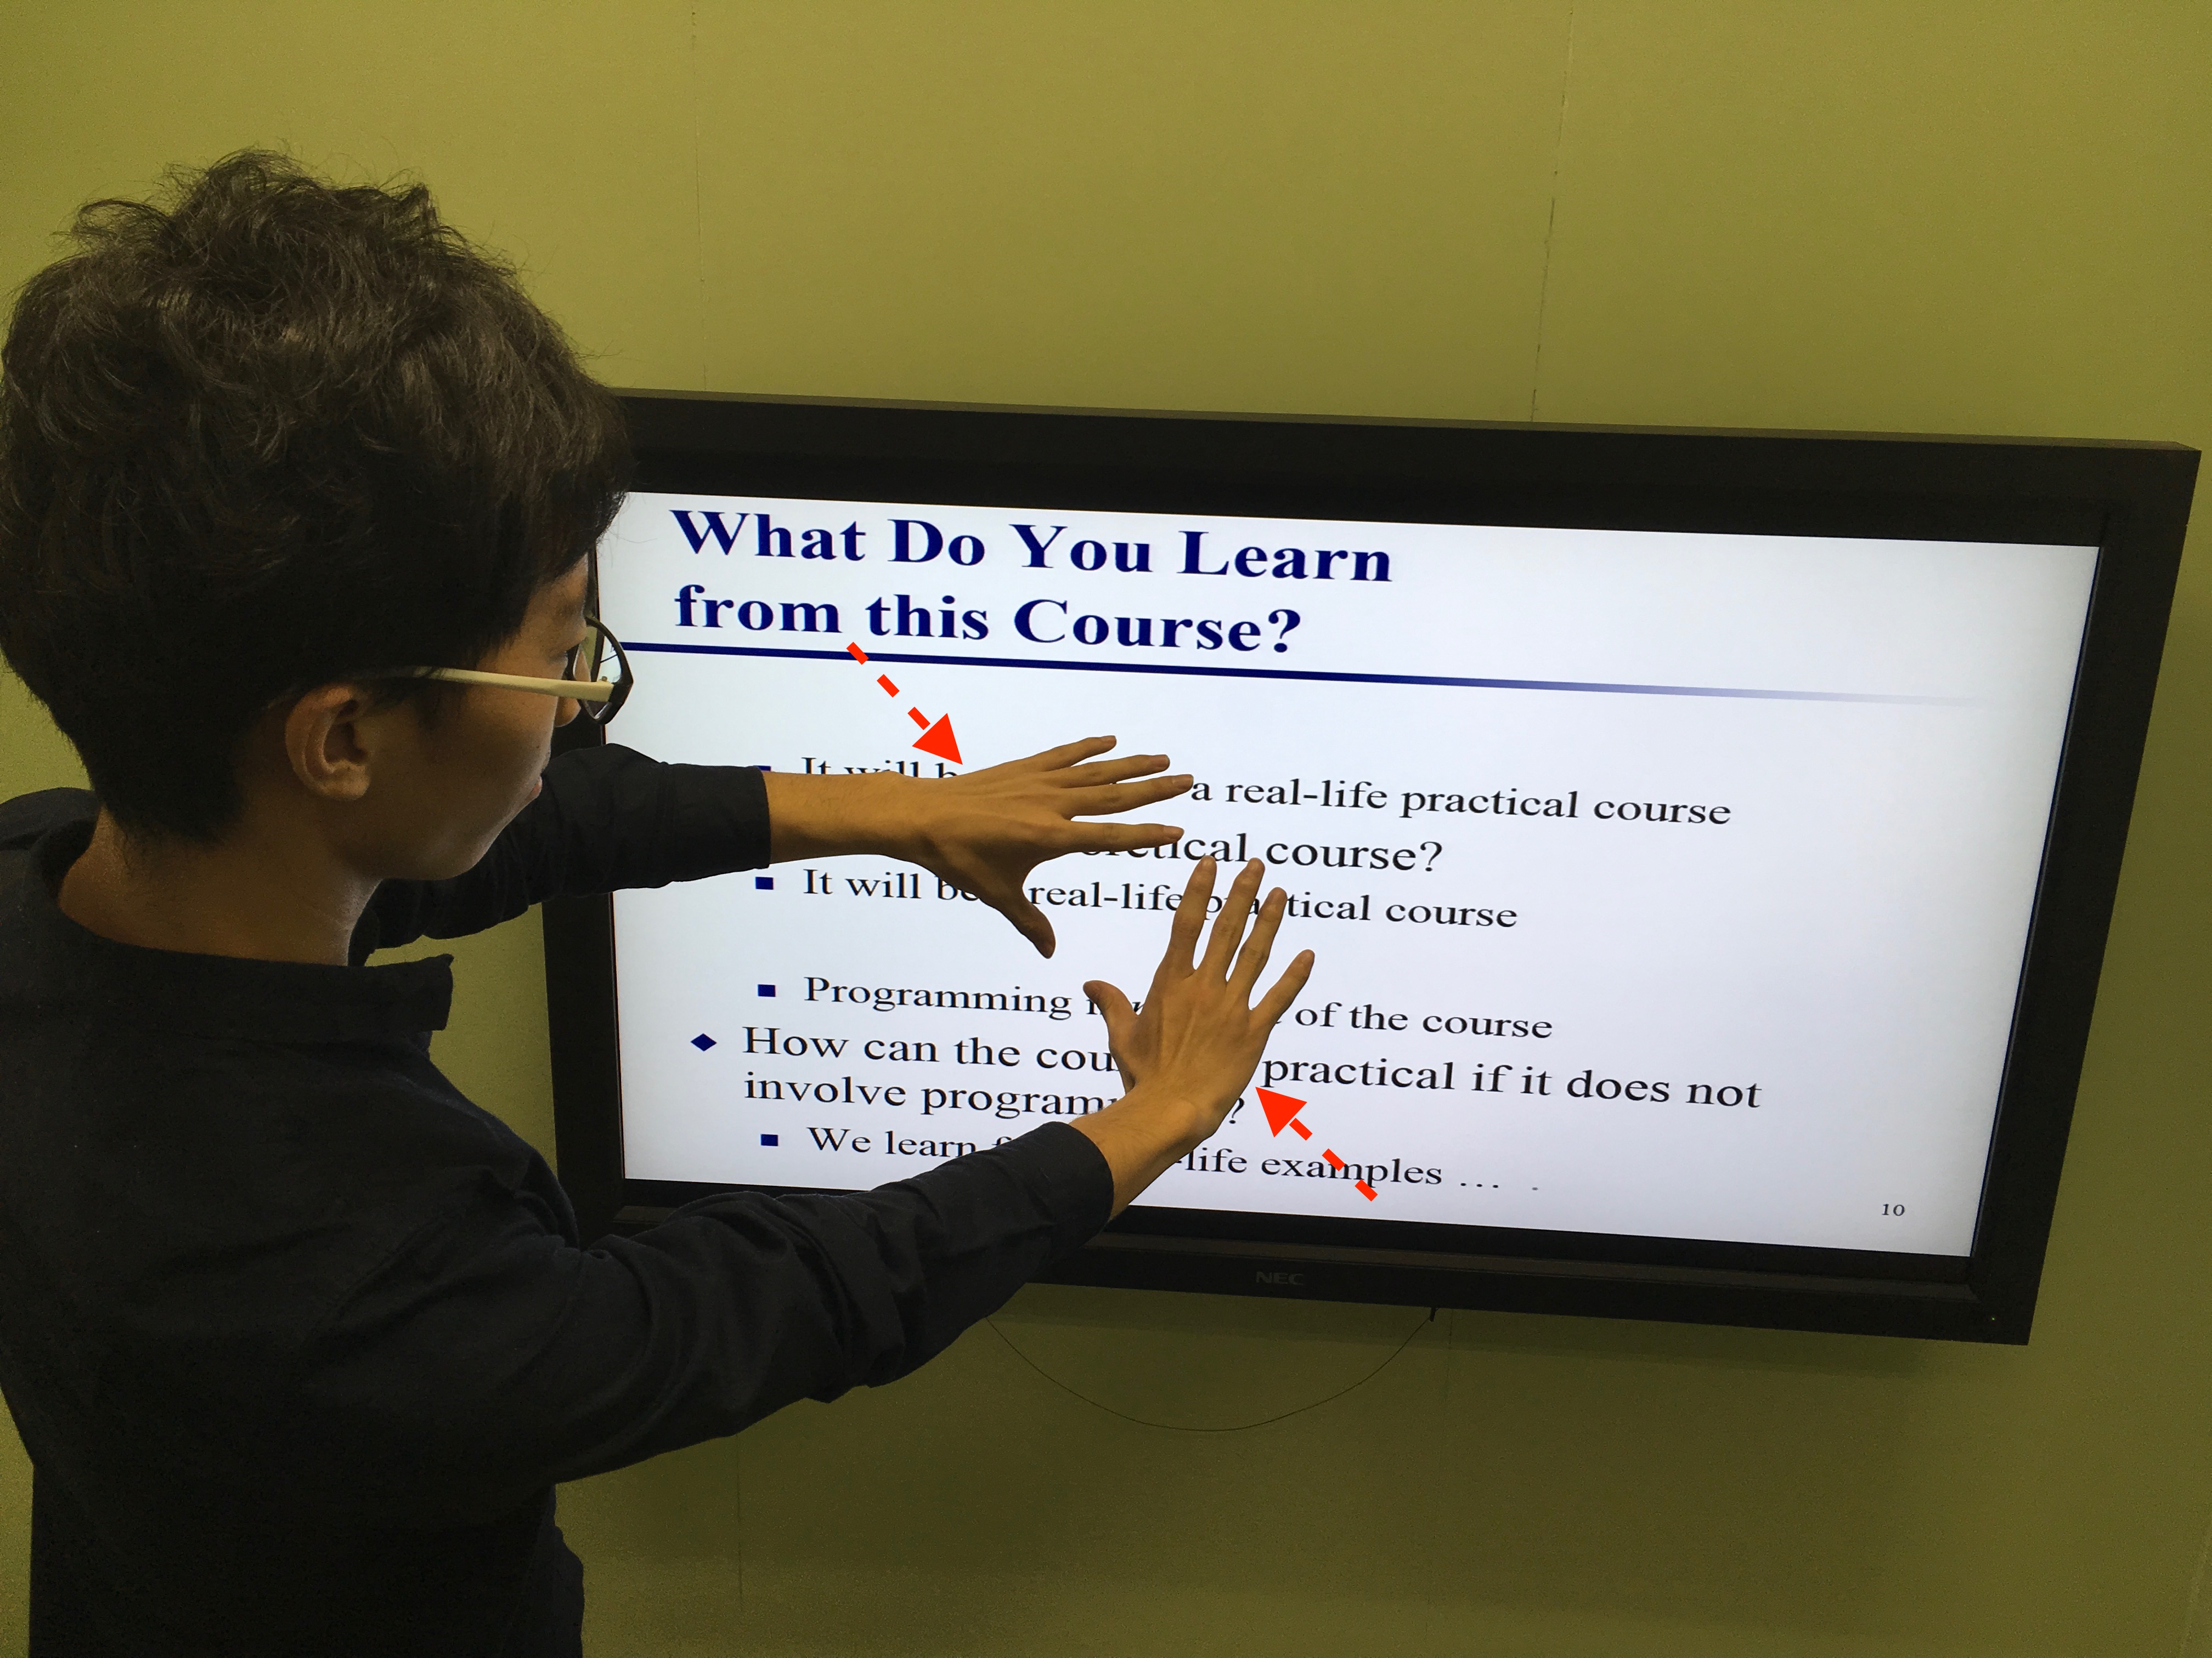

**4.2 Scenario 2 Play games**

The actions taken in playing Skyrim are:

1. Hold your fire

1.1 Raise your both hands to the level of the microphone speaker not making any movement.

1. Attack with single-hand magic
   1. Raise your hand to the level of the microphone speaker
   2. Move your hand forward and stretch your fingers.
2. Switch your destruction magic
   1. Raise your hand to the level of the microphone speaker
   2. Spin your wrist to switch.
3. Attack with both-hand magic
   1. Raise your both hands to the level of the microphone speaker
   2. Move both of your hands forward and stretch your fingers.
4. Attack with single-hand weapon
   1. Raise your right hand to the level of the microphone speaker and clench your fist
   2. Move your fist forward and backward.

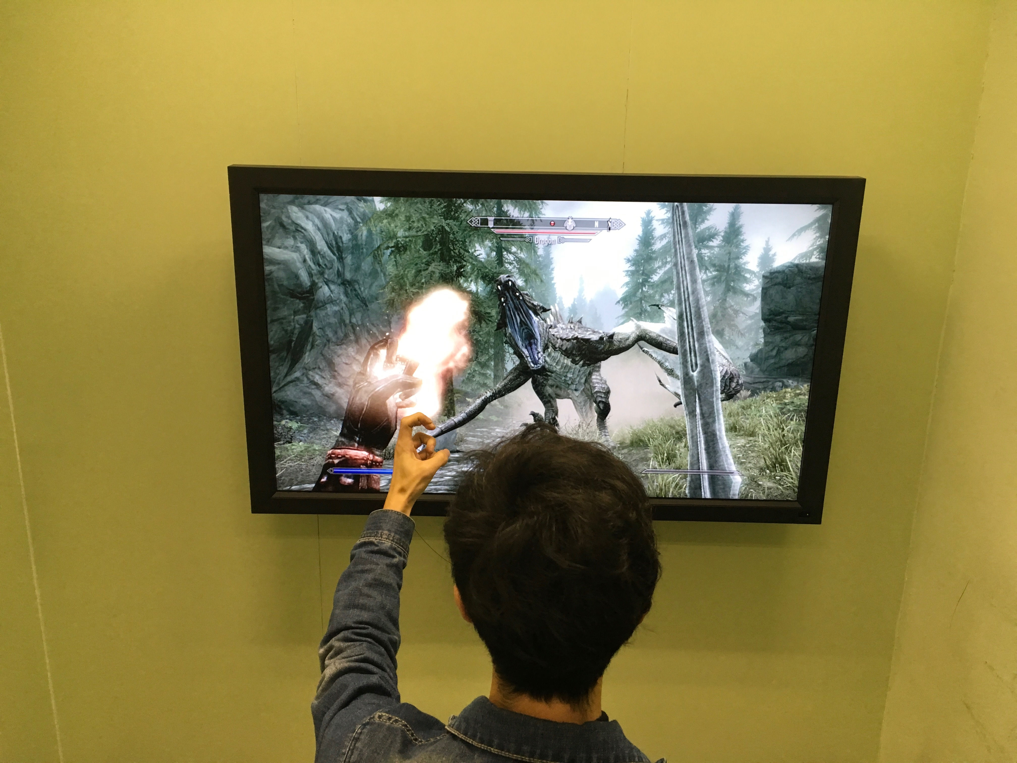 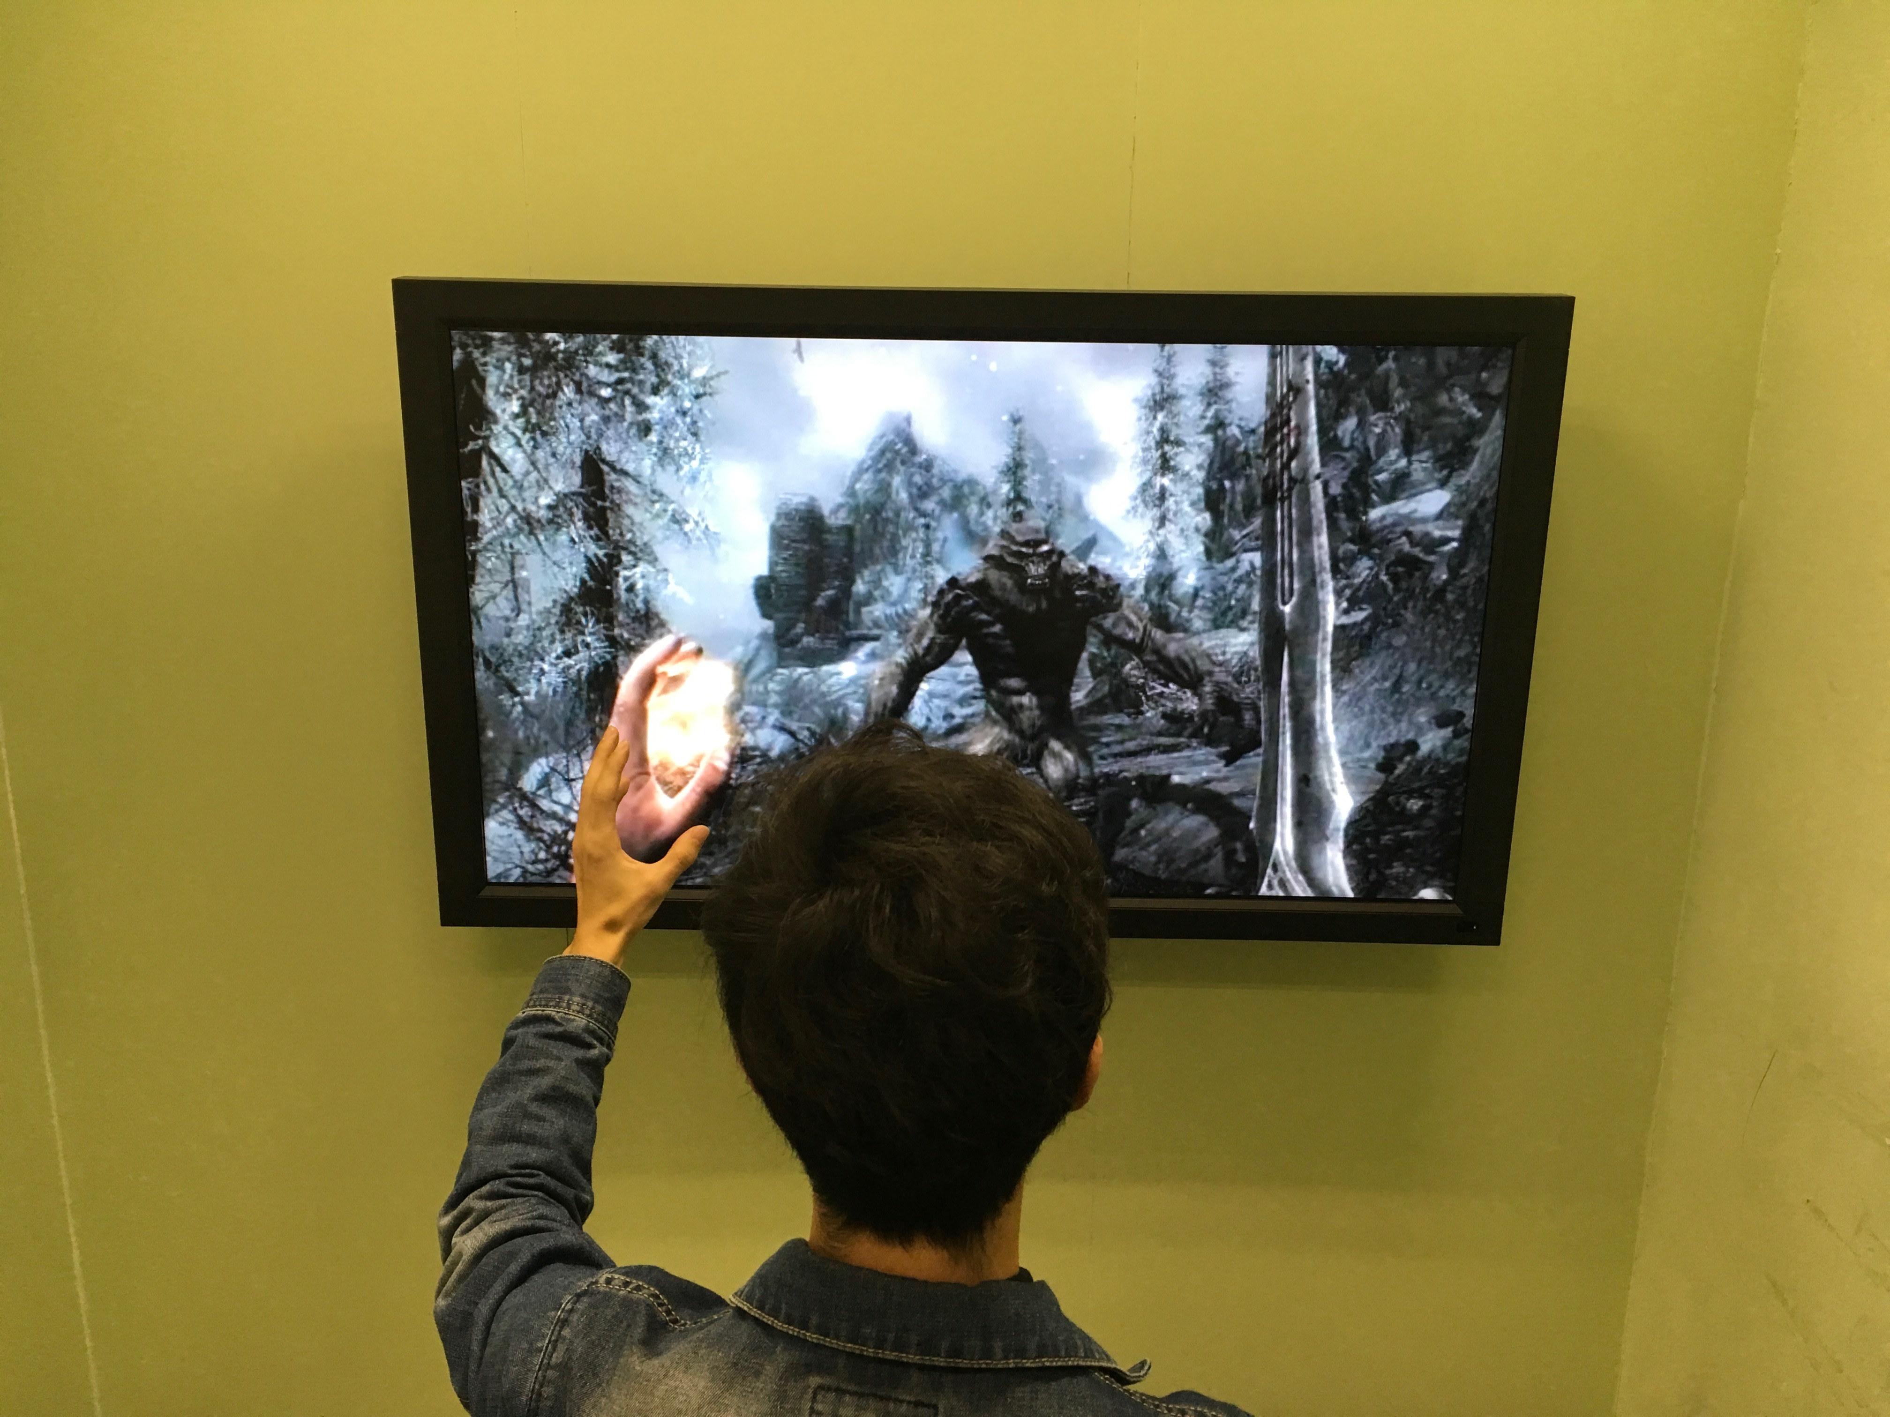

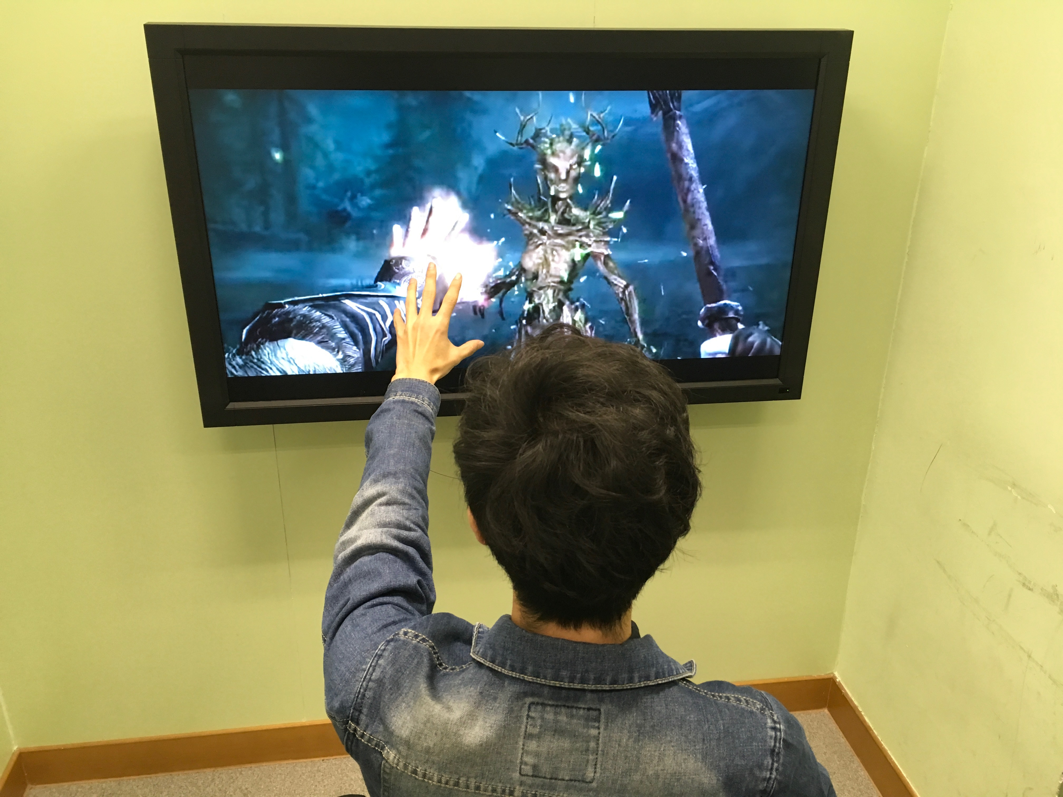 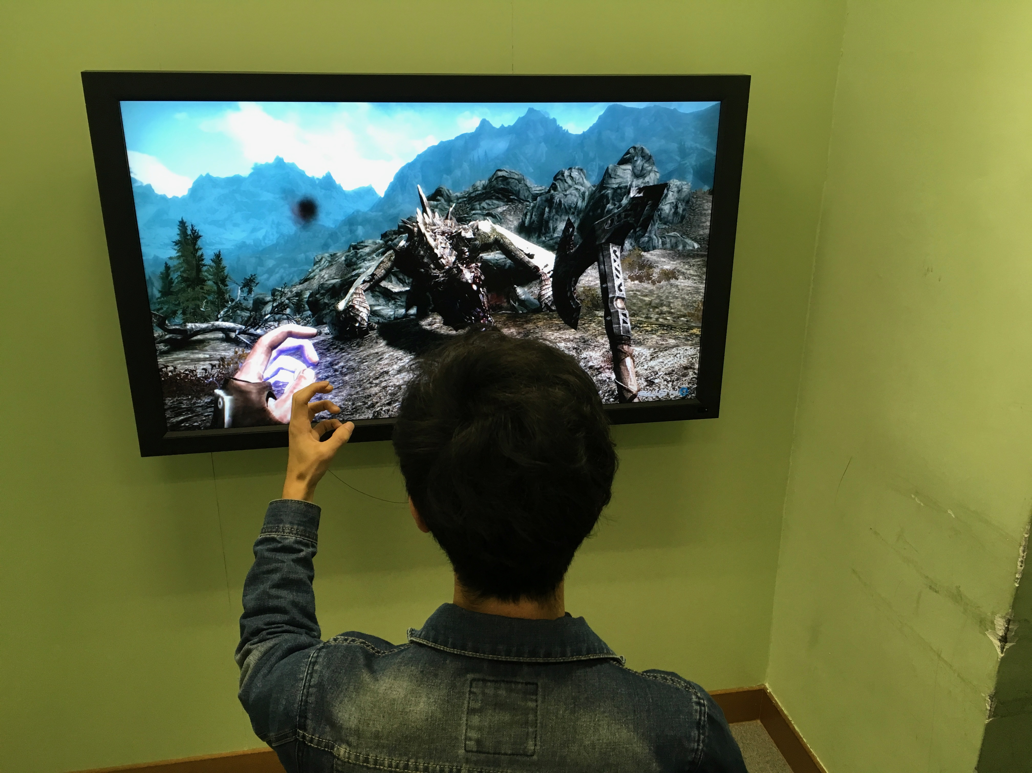

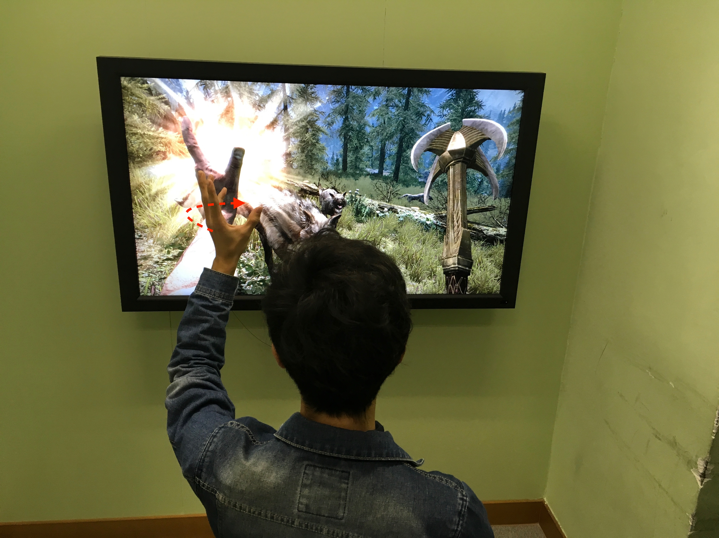 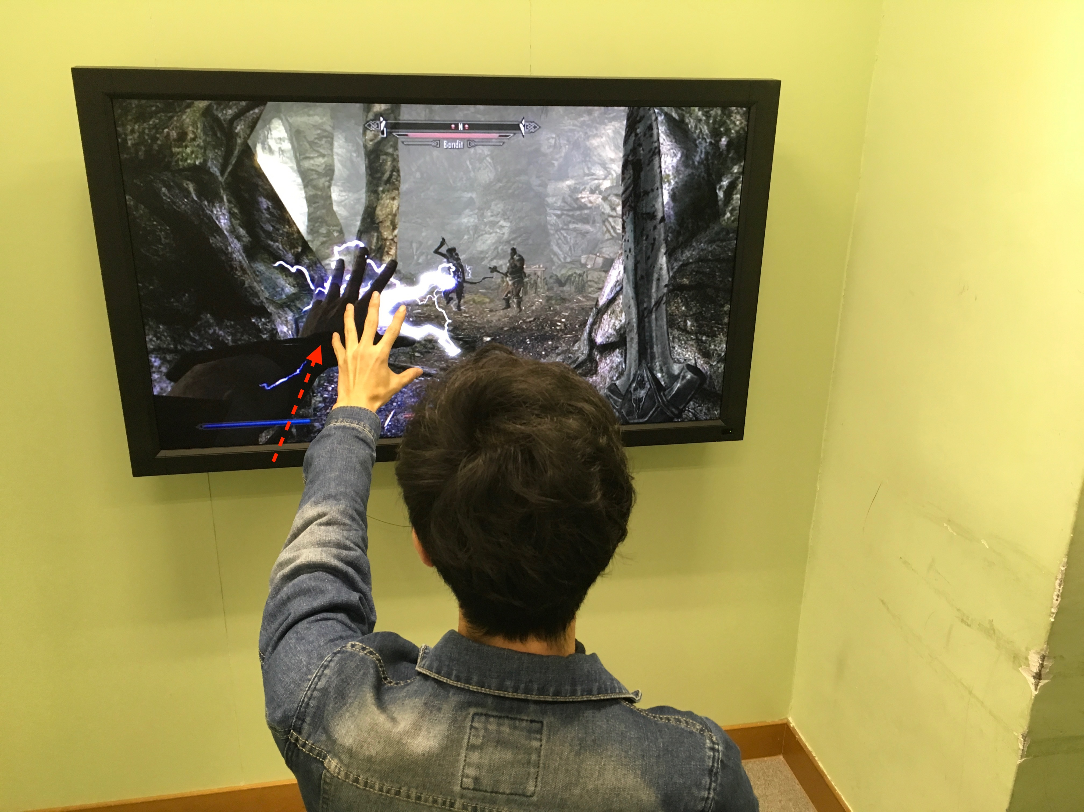

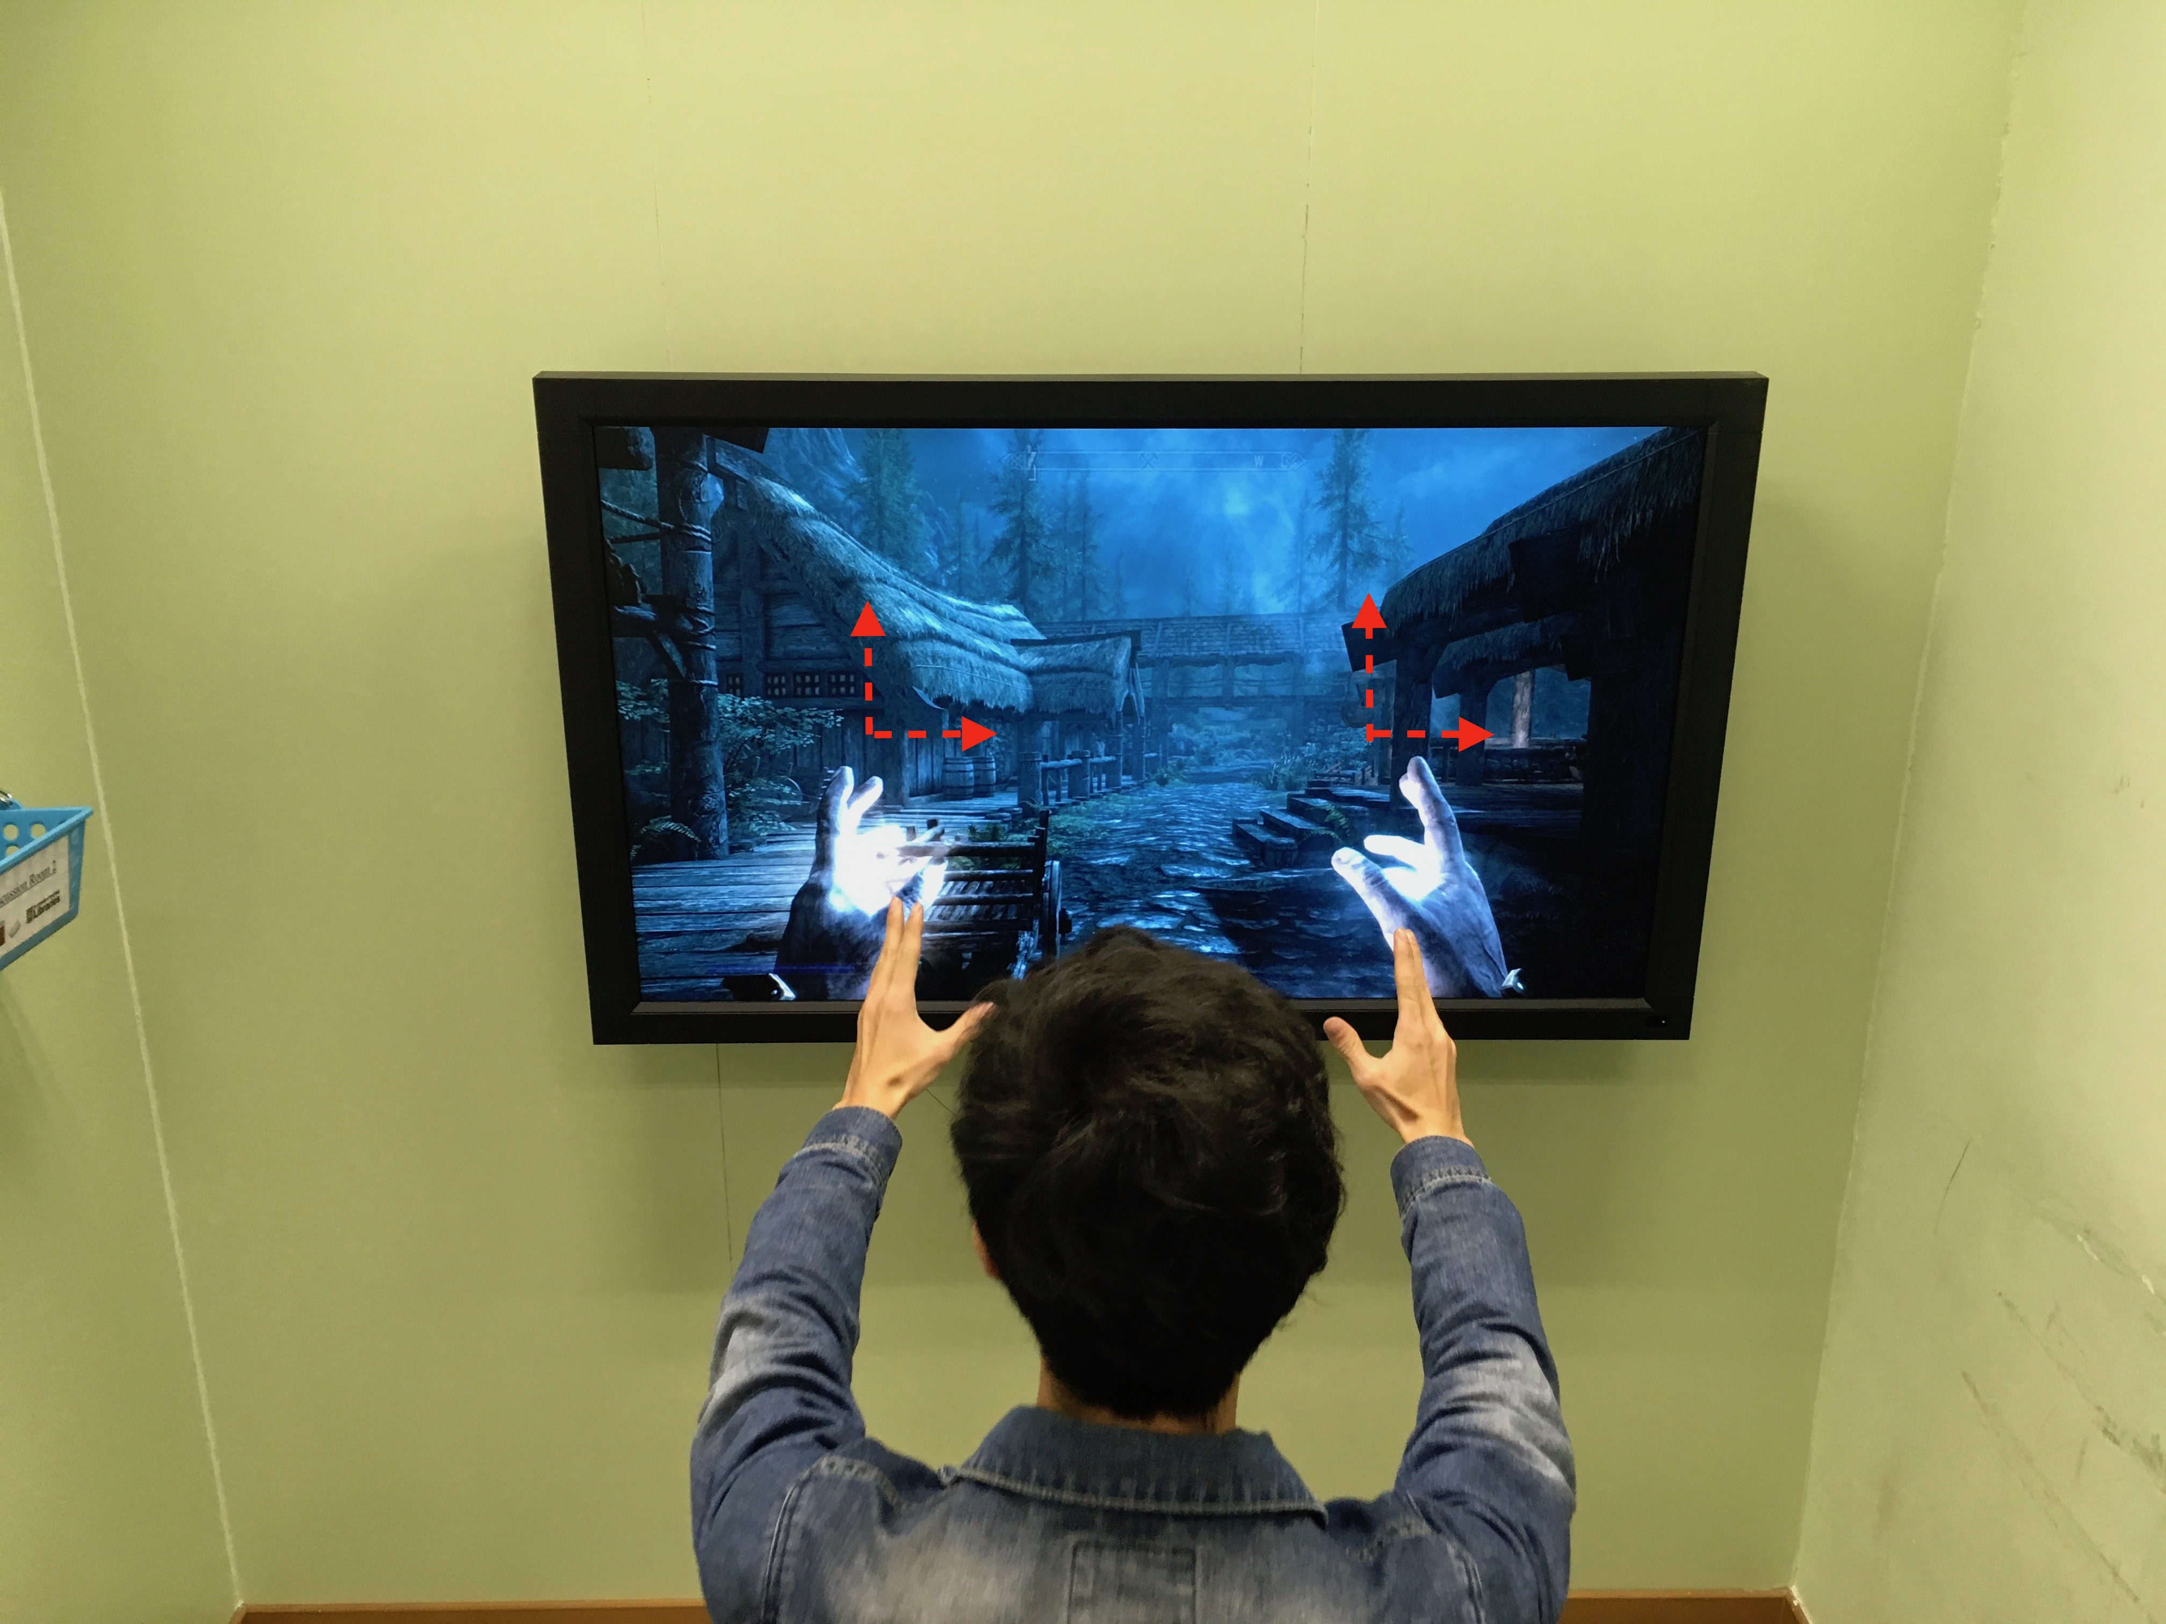

**4.3 Scenario 3 Make a phone call**

The actions taken to make a skype call:

1. Answer the skype

1.1 Move your hand from left to right in front of the microphone speaker of the device.

1. Reject the Skype

2.1 Move your hand from right to left in front of the microphone speaker of the device.

1. Hang on the call

3.1 Move your hand from upside to downside in front of the microphone speaker of the device.

1. Hang up the call

4.1 Move your hand from downside to upside in front of the microphone speaker of the device.

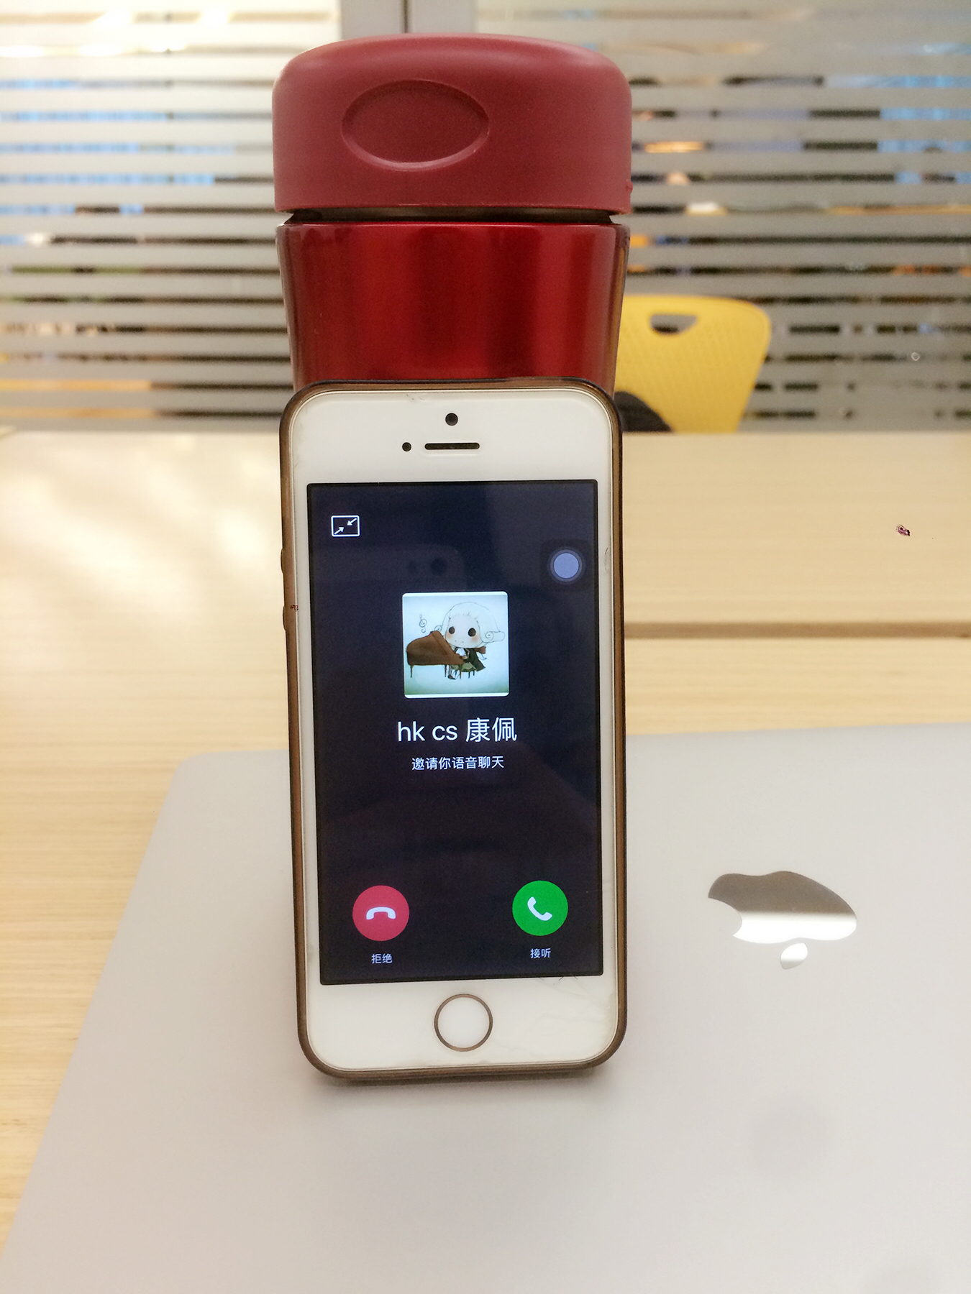

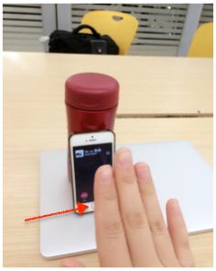 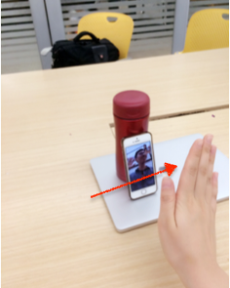

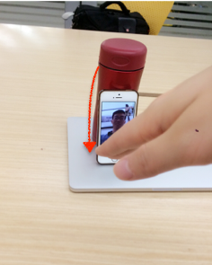 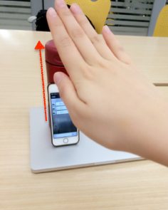

**4.4 Scenario 4 Computer operation**

The action of computer operation is

1. Switch pages

1.1 Let the hand sweep from the right edge of the computer to the left edge.

2. View multiple pages

2.1 Facing the screen to open the palm , and the screen shows a number of pages which have been opened.

2.2 Closing the palm and doing the grasp action, the screen will show you the current used page.

3. Turn page down

3.1 Let the hand sweep from the top edge of the computer to the bottom edge.

4. Change the size of the images

4.1 Hands in the middle of the screen, and diagonally open the palm until the edge of the screen.

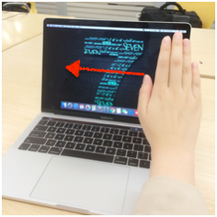 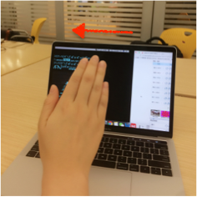

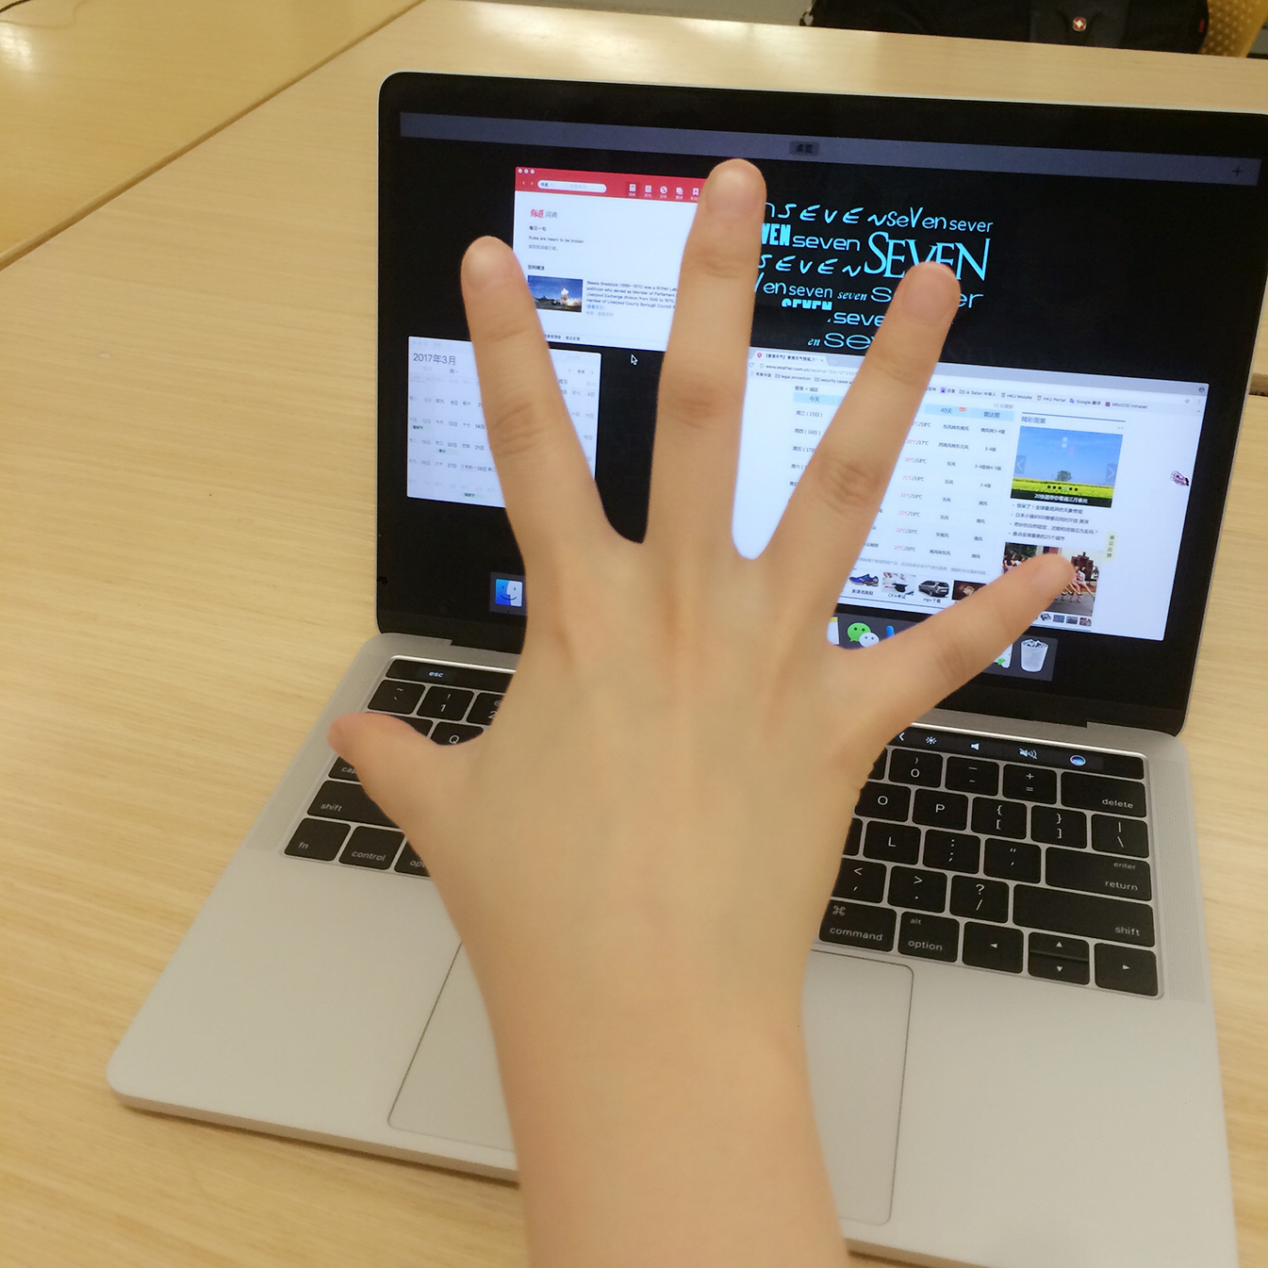 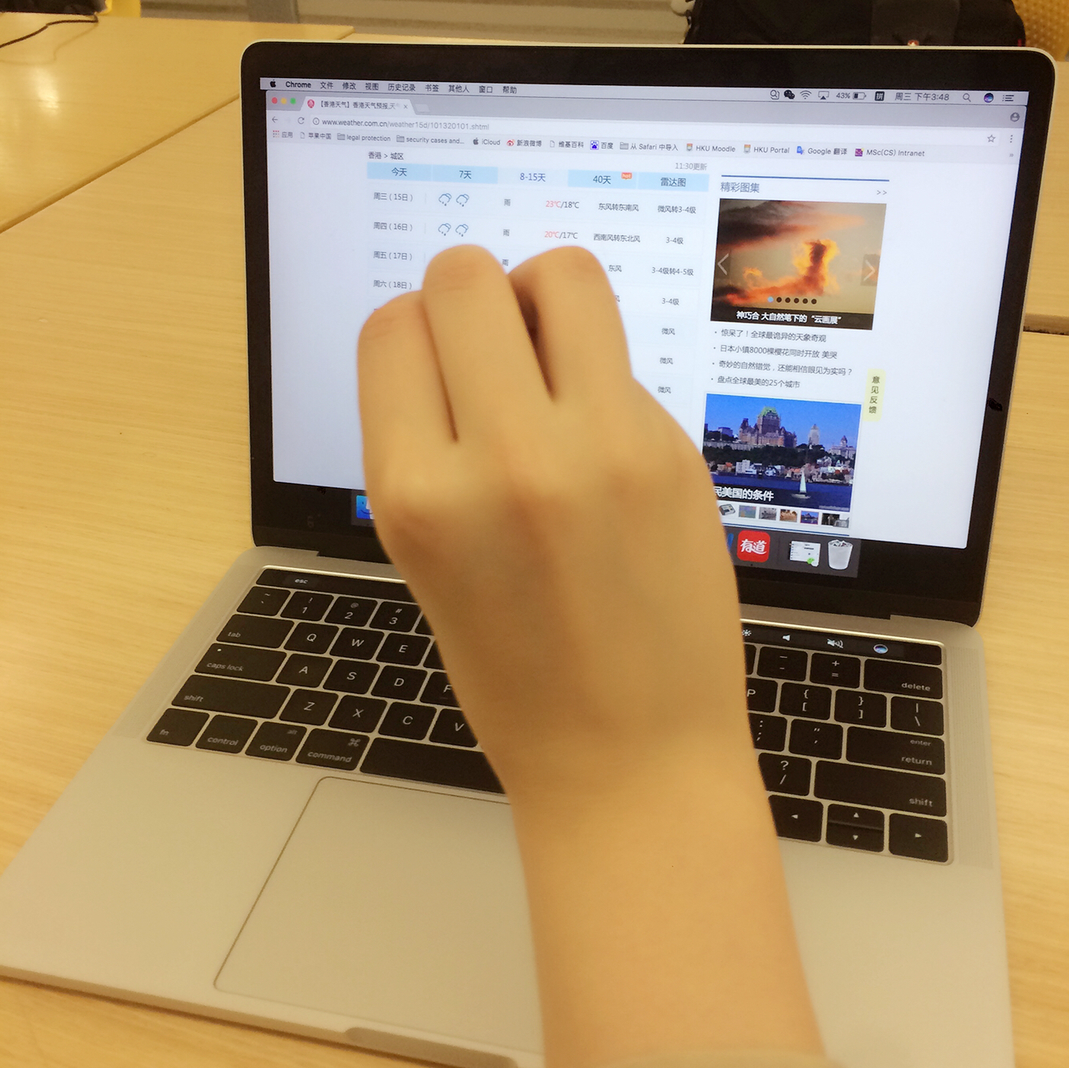

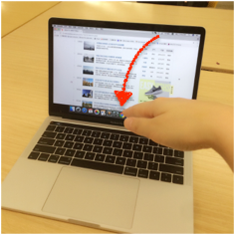 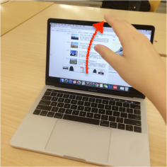

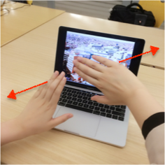 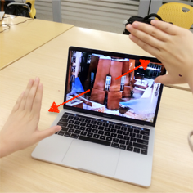

**4.5 Scenario 5 Driving**

The action of driving is

1. Start the music device

1.1 After starting the vehicle, let hand wave several times in front of the music device.

1.2 Using three fingers counterclockwise waving to improve the volume of music, and vice versa.

1.3 Swap the left and right to choose the song.

2. Accept or reject a phone call

2.1 When a phone call is coming, waving the hand to the left to answer the phone, or waving the hand to the right to refuse to call.

3. Switch the screen

3.1 Using two fingers to move from the right screen to the middle of the steering wheel, and put the information to the middle screen.

3.2 When the phone call is coming in the middle screen, waving the hand to the left to answer the phone, or waving the hand to the right to refuse to call.

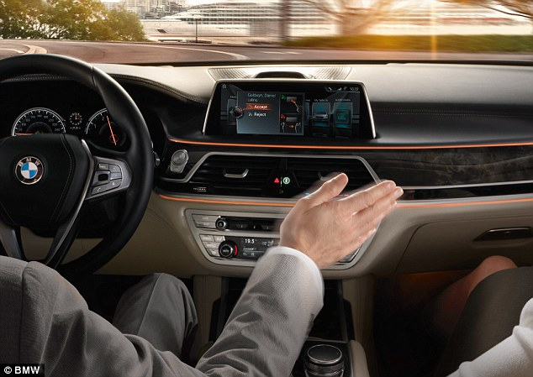

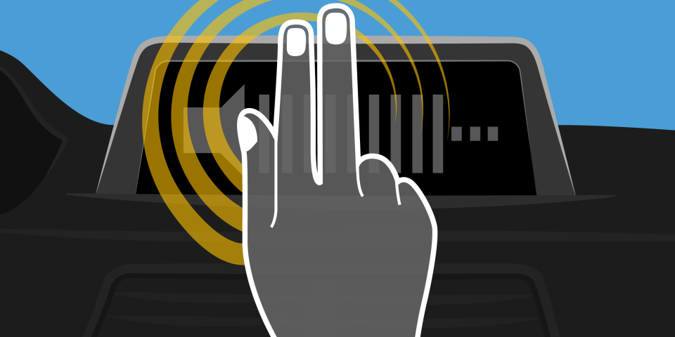

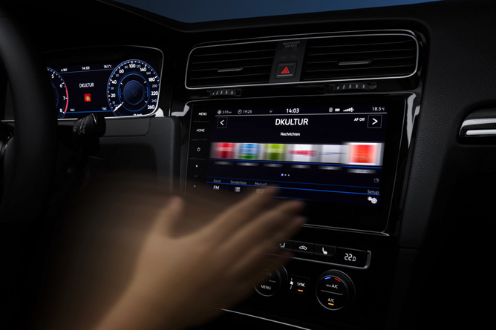

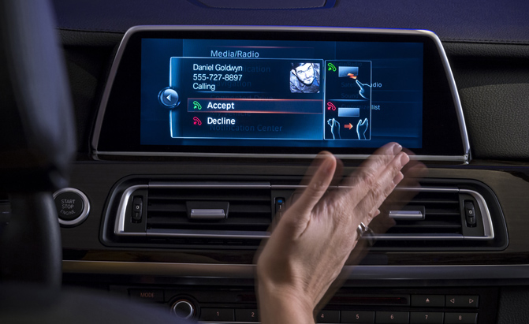

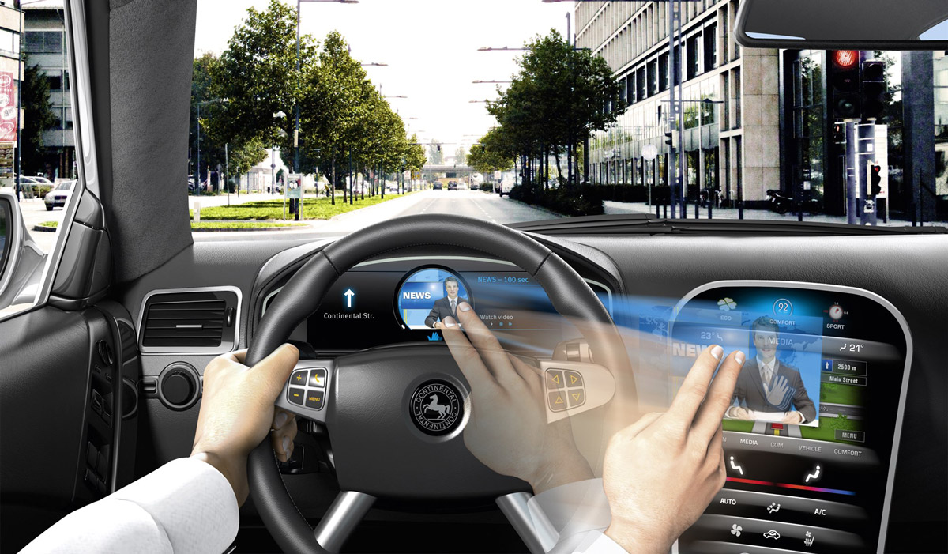

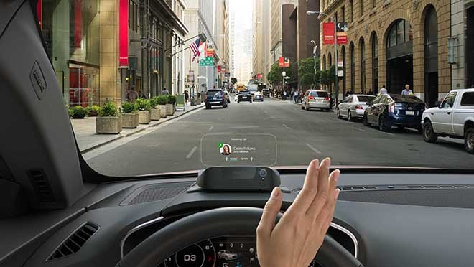

**4.6 Scenario 6 Reading machine in HKU**

The action of reading machine in HKU

1. View the information

1.1 When people want to switch the information in reading machine, they let the hand sweep from the right edge of the computer to the left edge, and vice versa.

2. Change the size of the images

2.1 Hands in the middle of the screen, and diagonally open the palm until the edge of the screen.

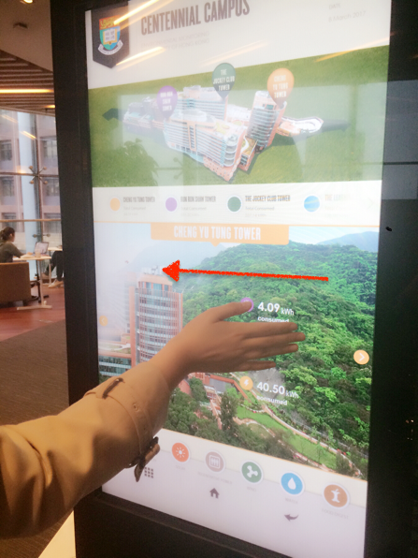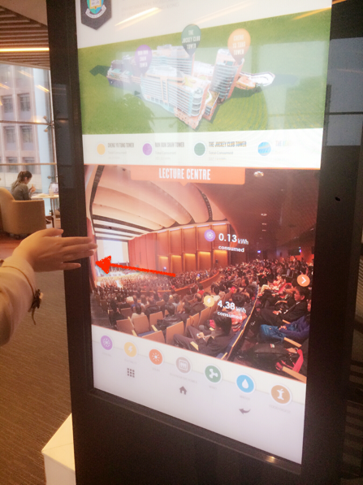

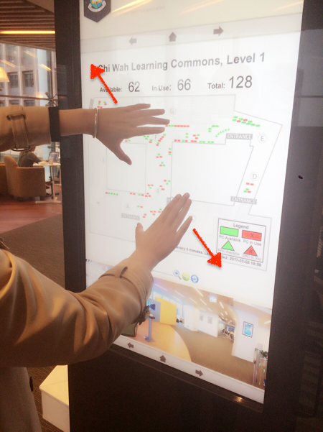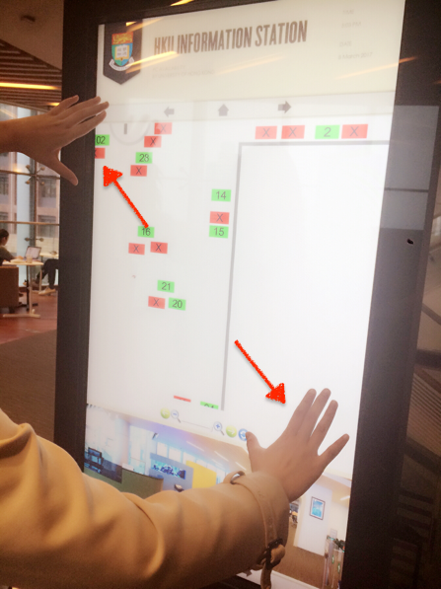

**4.7 Scenario 7 Self-timer**

The action of taking self-timer:

1. Take a picture

1.1 When you want to take a picture, you may easily push your hands towards the mobile phone, the device will detect this gesture and start the camera. It will show how many seconds left in the screen. It will automatically take a picture.

1.2 After self-timer, you may take your hands back or just move your hands away from the front of the mobile phone. It will stop the operation of the software.

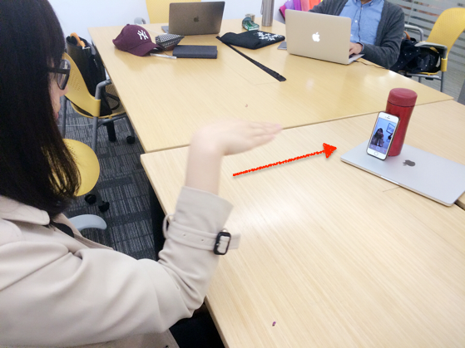 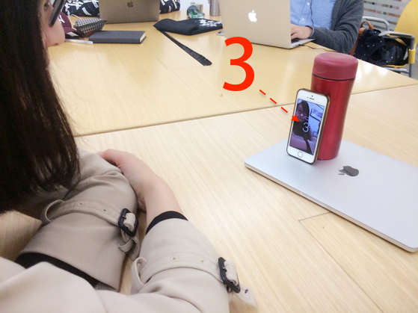

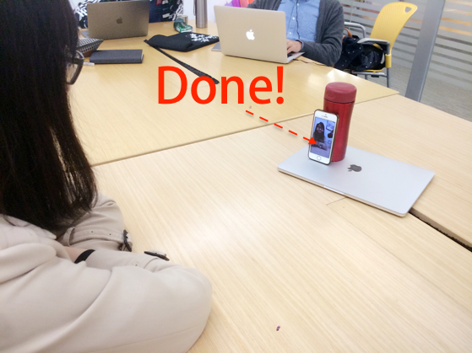

**5. 5. USABILITY TEST**

**5.1 Usability Goal**

In this session, we generate a questionnaire and do a survey among 12 individuals. The overall goal is to understand the responds of different people in terms of the usability of our product. The aspects of the test are but not limited to: the controlling usability, the consistency of the product, the flexibility and efficiency, familiar metaphors and languages used in the design, whether an error is likely to be prevented, whether system status is clearly shown in the product.

**5.2 Test Procedure**

We generate our questionnaire through a discussion among our group. Then we share it with members from our test groups. During the procedure, each of the twelve tested object are given choices indicating different response to the question. We collect the answer sheets and analysis them, then we visualize the results by some data visualization tools and an inference is made based on it.

**5.3 Tester background**

There are 12 students who come from hku cs department. The age is between 18 -25. They come from four different stream: financial, general, multi-media and information security.

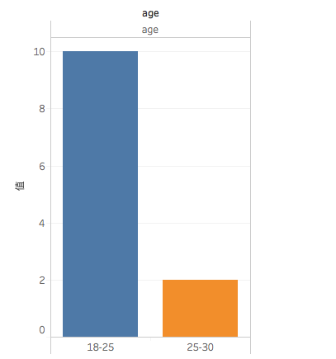

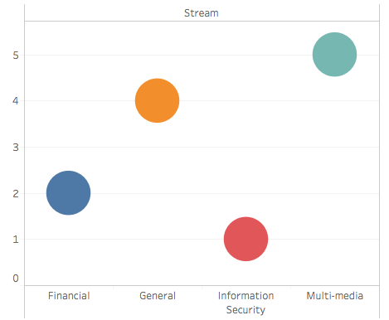

**5.4 User Interview**

1. Do you have used UI interactive tools before?

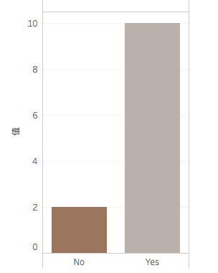

A. Yes B. No

2. Where do you know the UI interactive tools?

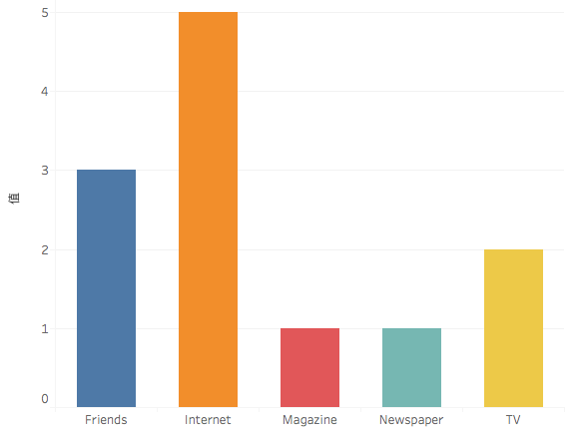

A. TV B. Newspaper C. Magazine D. Internet E. Friends F. School

3. Which kind of UI interactive tools you have known?

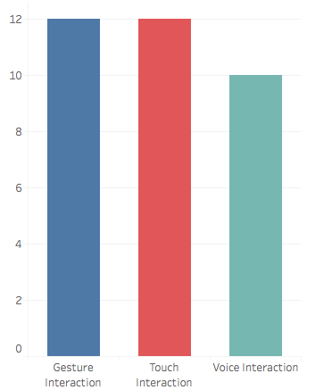

A. Gesture interaction B. Voice interaction C. Tactile interaction

4. Which place you think will use UI interaction?

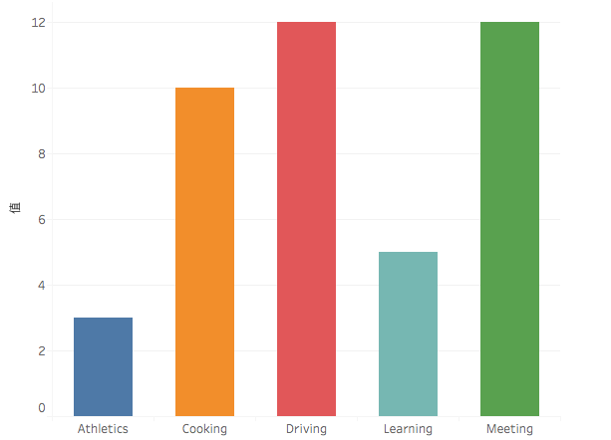

A. Driving B. Cooking C. Meeting D. Athletics E. Learning

5. Does the current way of interaction have met the individual needs?

A. Yes B. No

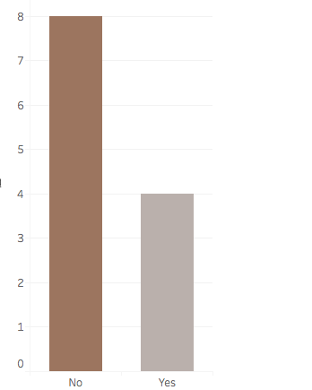

6. What are the advantages of Ultrasonic Wave Gesture Recognition?

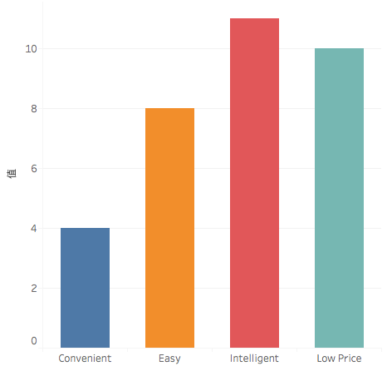

A. Convenient B. Easy C. Intelligent D. Low price

7. What are the disadvantages of Ultrasonic Wave Gesture Recognition?

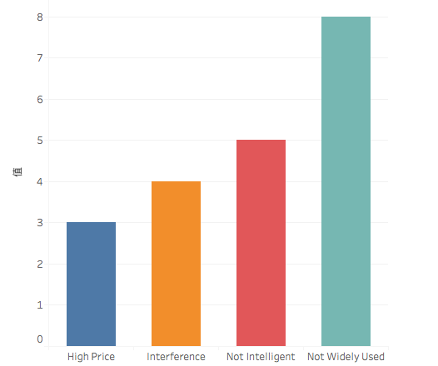

A. Interference B. Not widely used C. Not intelligent D. High price

8. Which is your expected UI interactive tools?

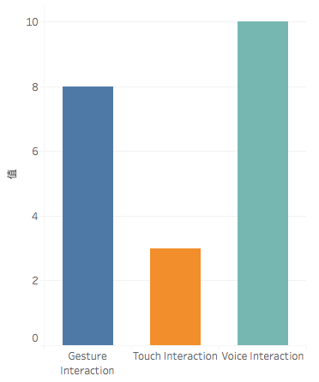

A. Gesture interaction B. Voice interaction C. Touch interaction

**5.5 Task Test**

1. Make a phone call

A new way to ease Tom’s trouble is we could implement the ultrasonic wave gesture interact with the device. For example, When the call is coming, but Tom is busy with other things. He could put his hands near the device and double wave to the device to answer the phone. After calling, he just wave his hand to the right to hand off the phone. If Tom do not want to answer the phone, he can wave the hand to the red button and reject the phone call.

2. Play games

A flexible way of interacting with gaming instruments is highly demanded. To fulfill the gap between traditional manipulating methods and these costly complex new interactions like Kinect, trade-off between consumption and performance must be considered. Otherwise, consider the tense atmosphere some games are trying to create, the lightening condition is always poor, which arise a major requirement of light-tolerance. With the help of soundwave reorganization of gestures, Michael will find a more comfortable and costless way to play video games even in poor lightening conditions.

**5.6 Task Response**

|  |  |
| --- | --- |
| **../Downloads/game-2.png Game play** | |
| efficient | **agree%20strongly.png agree.png not%20quite.png ../Downloads/哭脸.png**  **7 4 1 0** |
| convenient | **agree%20strongly.png agree.png not%20quite.png ../Downloads/哭脸.png**  **8 3 1 0** |
| natural | **agree%20strongly.png agree.png not%20quite.png ../Downloads/哭脸.png**  **11 1 0 0** |
| friendly | **agree%20strongly.png agree.png not%20quite.png ../Downloads/哭脸.png**  **6 4 1 1** |
| responds quickly | **agree%20strongly.png agree.png not%20quite.png ../Downloads/哭脸.png**  **7 5 0 0** |
| error avoidance | **agree%20strongly.png agree.png not%20quite.png ../Downloads/哭脸.png**  **4 4 3 0** |
| easy to use | **agree%20strongly.png agree.png not%20quite.png ../Downloads/哭脸.png**  **8 3 0 1** |

|  |  |
| --- | --- |
| **../Downloads/phone.pngPhone call** | |
| efficient | **agree%20strongly.png agree.png not%20quite.png ../Downloads/哭脸.png**  **8 3 1 0** |
| convenient | **agree%20strongly.png agree.png not%20quite.png ../Downloads/哭脸.png**  **7 4 1 0** |
| natural | **agree%20strongly.png agree.png not%20quite.png ../Downloads/哭脸.png**  **8 4 0 0** |
| friendly | **agree%20strongly.png agree.png not%20quite.png ../Downloads/哭脸.png**  **6 5 1 0** |
| responds quickly | **agree%20strongly.png agree.png not%20quite.png ../Downloads/哭脸.png**  **5 6 1 0** |
| error avoidance | **agree%20strongly.png agree.png not%20quite.png ../Downloads/哭脸.png**  **4 5 2 1** |
| easy to use | **agree%20strongly.png agree.png not%20quite.png ../Downloads/哭脸.png**  **9 2 1 0** |

absolutely agree: 

agree but could be better: 

not totally agree: 

disagree: 

**5.7 Analysis of Questions**

After task tests, we can get an initial conclusion that this new un-contact interaction is more natural and friendly to users. A potential problem is that people think this way may cause more recognition error which means the system may misunderstand what the user really want to do because of the system’s recognition accuracy, and that is really a technical challenge for us to overcome in the future. Overall the interaction based on ultrasonic wave gesture recognition will satisfy most of the users’ expectation and it’s very likely to improve people’s life style(improve efficiency greatly) in the near future.

**6. EVALUATION AND FINDINGS**

**6.1 Error Tolerant Rate on Task**

**6.2 Task Completion Rate**

**6.3 Time on Tasks**

**6.4 Comparision with other non-contact Interaction methods**

Previously, there have been many traditional technologies to achieve touchless human-machine interaction, namely, infrared gesture recognition, video gesture recognition, electric field gesture recognition, radar gesture recognition. Here the ultrasonic wave gesture recognition is very similar to radar gesture recognition. Below are the advantages and disadvantages between them.

|  |  |
| --- | --- |
| **Technology Scenarios** | **Comments** |
| Infrare oftend recognition | Its more direction oriented and low power consuming, but has limited recognition area range. It’s sensitive to environmental light. |
| Video recognition | It can recognize objects within quite a long distance, however, it’s power consuming and easily be effected by environmental light and it’s device demanding. |
| Electric field recognition | Very power saving but just can recognize objects near the device. |
| Radar recognition | It has very good recognition accuracy and the devices can be small. |
| **Ultrasonic wave recognition** | Don’t need extra devices because most of our mobile devices have micro-phone and speakers like smart phones, PC or tablets, so it’s very economic;  It’s power saving;  It can recognize objects in quite a long distance and wide range;  It’s not sensitive to light so will not be effected easily by the environment;  The main limitation of it is that currently its recognition efficiency and accuracy is still not good enough to be widely used on our devices. |

**6.5 Usefulness of the Functionalities**

Soundwave is a promising approach for sensing interactive in-air gestures with no additional hardware requirements. The ultrasonic based gesture recognition technology has the characteristics of light insensitivity, strong anti-noise ability, low computational complexity and low power consumption. It is easy to use and economical. This technology can guarantee a higher recognition rate, but also can reduce the time complexity and spatial complexity. High operating rate. It is suitable for use on wearable equipment

**6.6 Shortcomings and limitations**

Ultrasound based gesture control system is a very good approach for future human machine interaction. However, it is not without limitations. The main drawback of this approach is the dependence on the tone, which may be audible and may cause annoyance to children and pets. Also, we only tried to recognize our own gestures. When the data for others gestures are collected, the usefulness and robustness of this approach can be further improved. In addition, some devices include filtering to prevent tones generated or recorded at frequencies above 18 kHz. The potential solution to this problem is the "tone" of the user's digital music. In addition, the use of Doppler shift inherently limits the detection to the motion posture, and therefore requires other complex techniques for detecting static postures.

**6.7 Forecast**

Future work will focus on the following points. First, collect data from more people to get more gestures. Second, making real-time posture recognition possible. Third, the establishment of a user interface, easy to use. Last but not least, search for smaller and cheaper hardware devices so that they can be applied on mobile devices.

**7. CONCLUSION**

Currently, touchless human-machine interaction under ultrasonic wave gesture recognition is a more natural and practical choice compared with other existing ways. In the near future, touchless interaction will be highly demanded by people and it is very likely that ultrasonic wave will play the role even though there are still challenges and limitations exist. At the same time, it will be a large revolution to change totally from traditional touch or click interaction to un-contact interaction which will greatly change people’s life style, also there is still a long way for us to explore to implement that achievement. In this project, we have exhibit our imagination to explore more possibility and people’s potential expection based on the current technology, however absolutely there will be more possibilities and breakthroughs come up later which will be out of what we can imagine. We believe the current limitations will not be a problem in the near future and this technology will bring us more surprise to help improve our life and human and machine will communicate in a more natural and efficient way which will be really exciting. Finally, this project have include almost all the cases about ultrasonic wave gesture recognition technology and provide some extra ideas which are expected to be applied in the future.

**8. REFERENCES**

[1] Yang Qifan, Tang Hao, Zhao Xuebing, Li Yin, “Dolphin: Ultrasonic-based Gesture Recognition on Smartphone Platform.”2014 17th IEEE International Conference on Computational Science and Technology, 2014

[2] Chunyi Peng, Guobin Shen, Yongguang Zhang, Yanlin Li, Kun Tan, “BeepBeep: A High Accuracy Acoustic Ranging System using COTS Mobile Devices.” [International Conference on Embedded Networked Sensor Systems](http://www.baidu.com/link?url=WsMcr9D3B1D7XA5MaUlQjaAfX4c4b6IYazdHMUOAVQu4Mjq4AZnJ5F1UYb1zGBu7ZTjOwgS5V9wRbZCjwy6W_GokP0DojiUBnj7Ci2-0R1nnwBYO79ln0b_nJLiqFoZ94_mkz-CTyx0Yhbvjdl_FIaq4bVkWLKMHYOxcETStwRIg6VarQDcTqmJt6d7YbtAEvgNs9fNB-2RP9QDMdvYNc5Ilyn2cEAqP6xquVaaUeanD50N8naIicSTSHqnxvclJQzHM-BRLOCGX4n-5tNYhCXw2nfMeVlpazGphDl4PbiK)， 2007

[3] Kalgaonkar, K. and Raj, B. “One-handed gesture recognition using ultrasonic Doppler sonar,” In Proc. Of IEEE Acoustics, Speech and Signal Processing 2009.

[4] Stephen P. Tarzia, Robert P. Dick, Peter A. Dinda, Gokhan Memik, “Sonar-based measurement of user presence and attention.” In Proc. ACM UbiComp 2009.

[5] Junjue Wang, Kaichen Zhao, Xinyu Zhang, “Ubiquitous Keyboard for Small Mobile Devices: Harnessin Multipath Fading for Fine-Grained Keystroke Localization.”, International Conference on Mobile Systems, 2014

[6] [Przybyla, R.J](http://www.baidu.com/link?url=LKMKUN50-PWhVVi1J34BVYyvM6yHXQhpgrKHwRlgWV68oQAMeeGSZQYX5ZEuE5LY4dFicFx3xwVn3XSNVf7HklLamJxj6IdG1AIKkhDlO-2CsAwanZiPneAk9Bt9O_wLa6FJJYY2NzX9HCzh-8vtz1kwQnSGWMKBcAbdBmyeKfQQoSueIYeFq-oa1Jaeqdcp) , [Hao-Yen Tang](http://www.baidu.com/link?url=_fCTd-dFFwO68eXHfNnWufuSgqco_T4OKXvUDUVrRQy3zgZwt8cQTXOxz3N9eSq2sojV_ZcV4Hr5awWc_Q403i30Wnp9VN5BdjTA3PuJpk-EGFJTK7FaiVcnCZi95Ow9z6dhjyoWyl9gn0T6lqMtiI6heQLWw1uJ_h_yMpgaS3zp1-QnS7YU7lHXAumJZ3QE) , [Shelton, S.E](http://www.baidu.com/link?url=NAxm04R5FvA7FAiSbaLoMOBgRHmTG67Wi6gf0kCeiktMnBMbApd-5PLauSuwNeTp6_qRxtaH04ahjBif_G0wFsUYwejJqUQI_uy6l4HCrcQESpk9bg_zSM4AQLm_1tu-ISDPcmLKHcvhgCdlyLkCMDmROxYJmCqifd4UonGq-XHdRo2Zjg4xfiy20zAewqj_), “3D ultrasonic gesture recognition.” Solid-state Circuits Conference Digest of Technical Papers, 2014, 57:210-211

[7] Kun Jin, Arye Nehorai, “Ultrasonic Gesture Recognition with Neural Network

”, Washington University in St. Louis, Available: http://www.ese.wustl.edu/~nehorai/ugr/Report_UGR_Kun_Jin_2016.pdf

[11] SoundSense: 3D Gesture Sensing using Ultrasound on Mobile Devices Available: http://119.90.25.34/mrorz.github.io/files/soundsense.pdf

[12] Travis Deyle, Szabolcs Palinko, and Erika Shehan. Fingermic: A lightweight bio-acoustic finger gesture interface for hand-full computing.

[13] K. Kalgaonkar and B. Raj. One-handed gesture recognition using ultrasonic doppler sonar. In Acoustics, Speech and Signal Processing, 2009. ICASSP 2009.  IEEE International Conference on, pages 1889{1892, April 2009.

[14] Sidhant Gupta, Daniel Morris, Shwetak Patel, and Desney Tan. Soundwave: Using the doppler effect to sense gestures. In Proceedings of the SIGCHI  Conference on Human Factors in Computing Systems, CHI '12, pages 1911{1914, New York, NY, USA, 2012. ACM.

[0] Joseph Paradiso, Craig Abler, Kai-yuh Hsiao, Matthew Reynolds, “The magic carpet: physical sensing for immersive environments.” In Extended Abstracts on Human Factors in Computing Systems, Page 277-278, 1997